# EX.NO: 1 CREATING PRESENTATION USING MS OFFICE DATE:09.09.25

**AIM:**

To create a PowerPoint presentation using Microsoft PowerPoint by inserting text, images, design themes, animations, and transitions.

# ALGORITHM:

1. Start PowerPoint
   * Click Start Menu → Microsoft Office → PowerPoint.
   * Select Blank Presentation.
2. Choose a Design Theme
   * Go to the Design tab.
   * Select any theme or variant.
3. Create Title Slide
   * Click on the Title Slide layout.
   * Enter the Title and Subtitle.
4. Insert New Slides
   * Go to Home → New Slide.
   * Choose required layout.
5. Add Text Content
   * Type text and use formatting tools.
6. Insert Images/Shapes/Charts
   * Go to Insert tab and choose the required object.
7. Apply Transitions
   * Go to Transitions tab.
   * Apply effects and duration.
8. Add Animations
   * Select an object and apply animation.
   * Use Animation Pane.
9. Insert Slide Numbers & Footer
   * Insert → Header & Footer.
10. Save & Run Slideshow
    * File → Save As → .pptx
    * 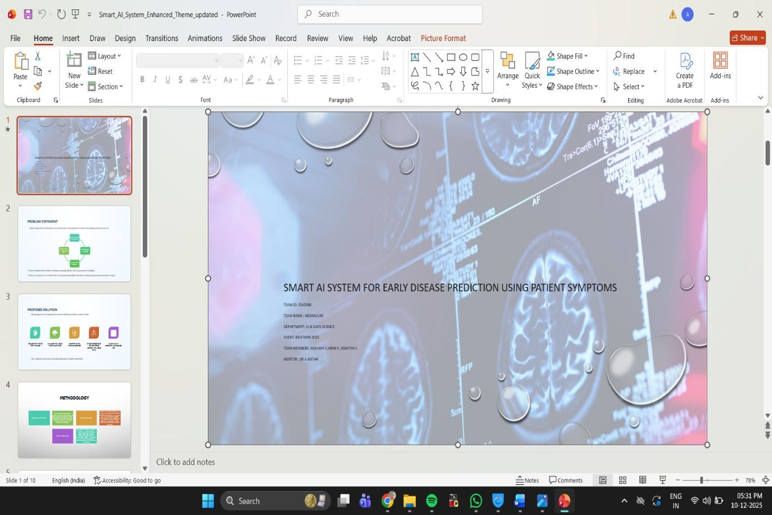Press F5 to run slideshow.

# SAMPLE OUTPUT:

**RESULT:**

Thus the presentation was created successfully using MS powerpoint

# EX.NO: 2 LEARNING TOOLS OF PHOTOSHOP DATE:09.09.25

**AIM:**

Learn the Adobe Photo Shop Tools such as Move & Selection Tools, Crop & Slice Tools, Retouching & Healing Tools, Painting & Drawing Tools, Vector & Shape Tools, Navigation Tools, Eyedropper & Measurement Tools and Extra Tools and do the following,

* Adding text using Type tool
* Make Selections with the Magnetic Lasso Tool
* Replace unwanted content with the patch tool and Apply filter to it
* Work with the smudge tool to smooth and blend colors.
* Blur areas in an image with Blur tool.
* Remove background using eraser tool
* Paints with pixels from another area using Clone Stamp Tool (S)

**ALGORITHM:**

# ADDING TEXT USING TYPE TOOL PROCEDURE:

Steps to Use the Text Box Tool in Photoshop

#### Select the Type Tool (T)

Click the **T** icon in the toolbar or press **T** on your keyboard.

#### Click and Drag to Draw a Text Box

Drag your mouse to create a rectangular area where you want your text.

#### Type Your Text Inside the Box

Start typing—your text will automatically wrap inside the box.

#### Format the Text

Use the **Options Bar** at the top to change font, size, color, alignment, and spacing.

#### Confirm and Adjust

Click the ✔️ **Checkmark** or press **Ctrl + Enter** to apply. You can resize the box or move it with the **Move Tool (V)**. **SAMPLE OUTPUT**:

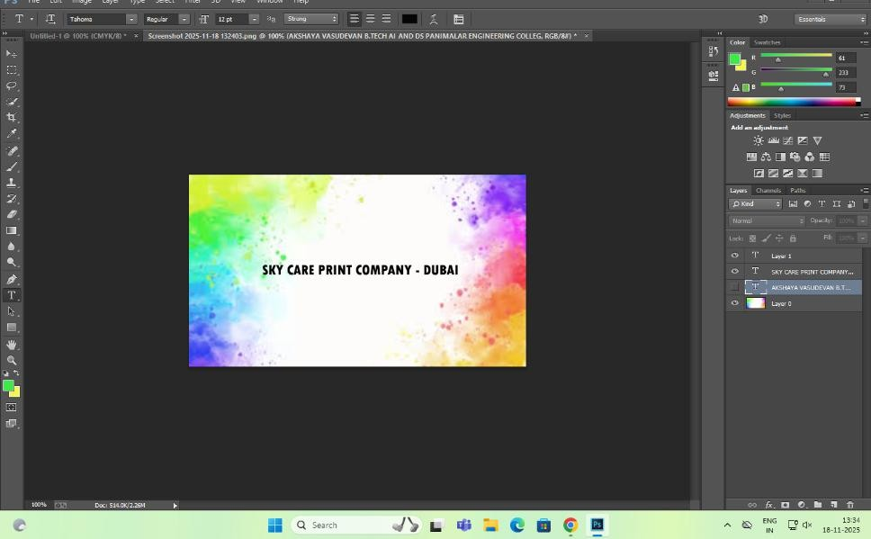

# MAKE SELECTIONS WITH THE MAGNETIC LASSO TOOL PROCEDURE:

1. **Open Your Image**:
   * Open Adobe Photoshop.
   * Go to File > Open and select the image you want to work with.
2. **Select the Magnetic Lasso Tool**:
   * In the toolbar, right-click on the Lasso Tool icon and select the Magnetic Lasso Tool.
3. **Make a Selection**:
   * Click on the edge of the object you want to select to set the starting point.
   * Move your cursor along the edge of the object. The Magnetic Lasso Tool will automatically snap to the edges based on color and contrast.
   * Click to add anchor points manually if needed.
   * Close the selection by clicking on the starting point or pressing Enter.

**SAMPLE OUTPUT**:

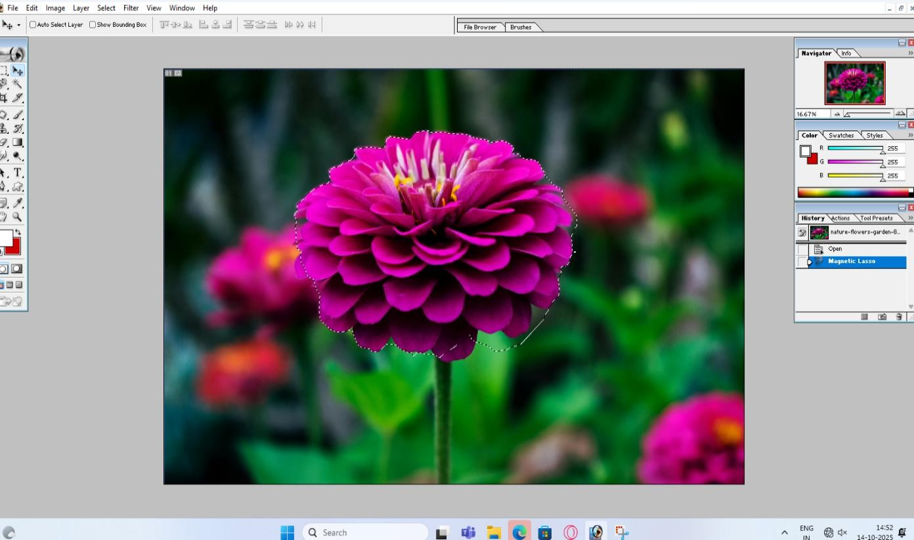

1. **REPLACE UNWANTED CONTENT WITH THE PATCH TOOL AND APPLY A FILTER TO IT**

**PROCEDURE:**

* 1. **Select the Patch Tool**:
     1. In the toolbar, right-click on the Spot Healing Brush Tool and select the Patch Tool.
     2. Alternatively, press J on your keyboard and cycle through the tools until you get to the Patch Tool.

#### Make a Selection with the Patch Tool. to replace

* + 1. Click inside the selection and drag it to the area you want to use as the source for the patch.

#### Draw a selection around the unwanted content you want

Release the mouse button to apply the patch.

#### Apply a Filter:

* + 1. With the patched area still selected, go to Filter > Blur > Gaussian Blur (or any other filter you want to apply).
       - Adjust the settings as needed and click OK.

# SAMPLE OUTPUT:

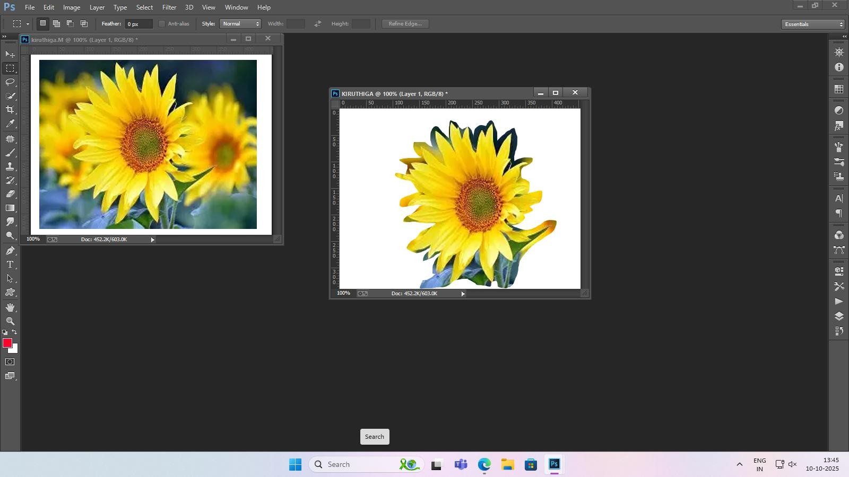

1. **WORK WITH THE SMUDGE TOOL TO SMOOTH AND BLEND COLORS.**

**Smudge Tool** : allows you to mix or blend the content in an area of your image.

# PROCEDURE:

1. Select the **Smudge Tool** from the toolbar.
2. Adjust the brush size and strength to suit your blending needs.
3. Click and drag the tool over the area where the orange and purple colors intersect, gently smudging them together to create a seamless gradient.

# SAMPLE OUTPUT:

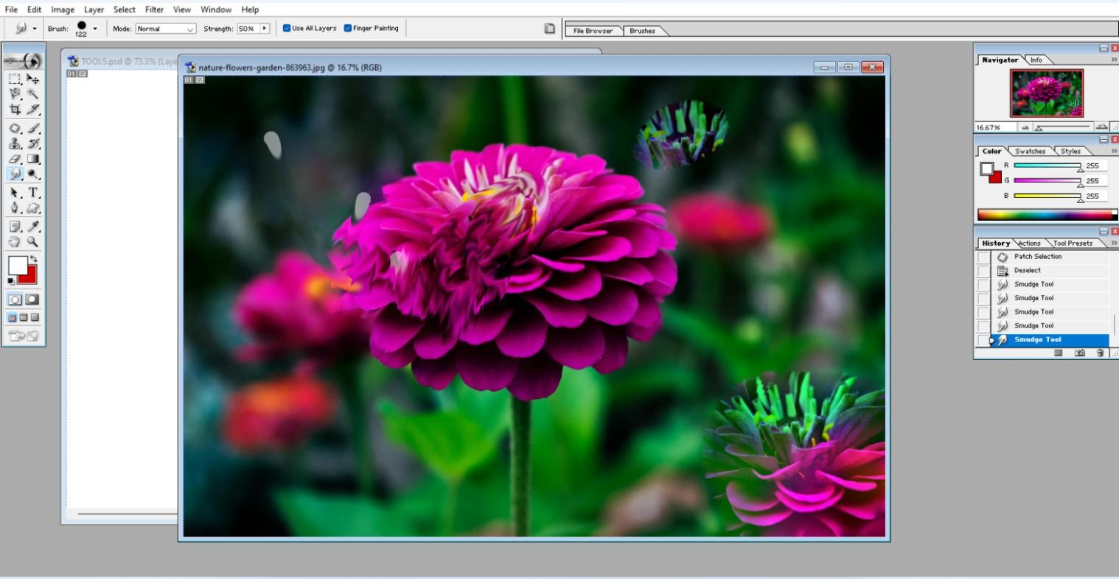

1. **BLUR AREAS IN AN IMAGE WITH BLUR TOOL.**

**BLUR TOOL : blur Areas in an Image with the Blur Tool**

# PROCEDURE:

#### Open the Image

* + Open the image of the bird in Photoshop.

#### Select the Wings

* + Use the **Lasso Tool** or **Quick Selection Tool** to select the wings of the bird.
  + Refine the selection using **Select and Mask** (found in the options bar) for a smoother edge, if needed.

#### Create a New Layer

* + After selecting the wings, press **Ctrl + J** (Windows) or **Cmd + J** (Mac) to duplicate the selected area to a new layer.

#### Apply Blur

* + With the new layer selected, go to **Filter** > **Blur** > **Gaussian Blur** (for a smooth, even blur).
  + Adjust the **Radius** slider to control the intensity of the blur. A higher radius will create a more pronounced blur.

#### Adjust the Effect (Optional)

* + If you want a more focused blur on certain parts of the wings, use a **Layer Mask** to paint over the areas where you want to reduce the blur using a **soft brush** with low opacity.

#### Fine-Tune the Selection

* + If needed, use the **Eraser Tool** to erase any unwanted blur areas from the wings.

#### Final Adjustments

* + Zoom in and adjust the edges if the blur needs refining.
  + Once satisfied, **save the image** in your preferred format.

SAMPLE OUTPUT: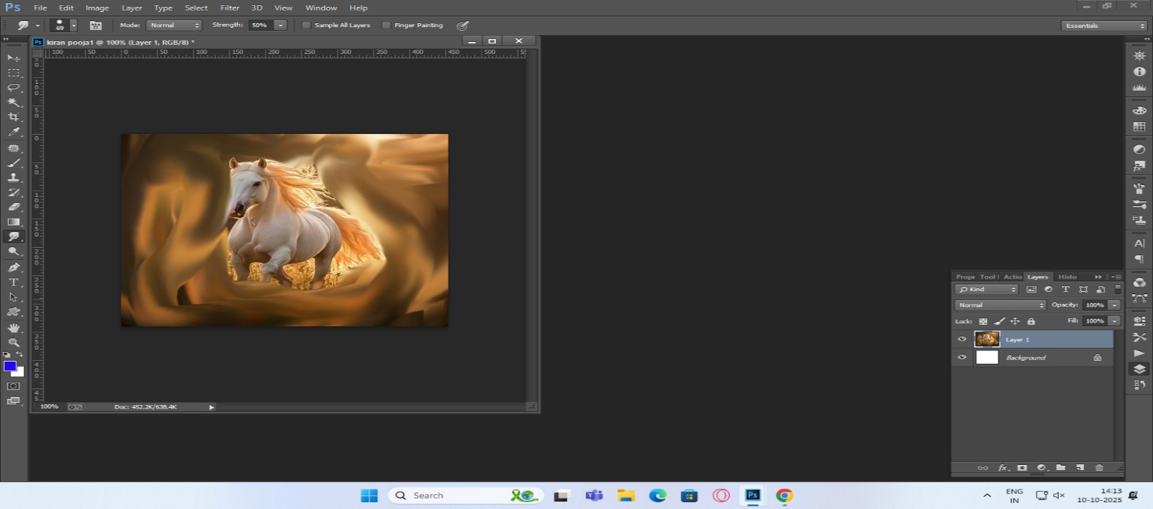

1. **REMOVE BACKGROUND USING ERASER TOOL**

**Background Eraser tool** in Adobe Photoshop.

1. Select the **Background Eraser tool** (E) from the toolbar. If you can’t find the **Background Eraser tool**, select and hold the **Eraser tool** to show the other related tools, and then select the **Background Eraser tool**.

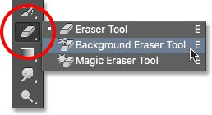

1. In the tool options bar, do the following:
   * Select the Brush size, hardness, and spacing according to your requirement.
   * Specify Sampling, Limits, and Tolerance.
   * Turn on the **Protect Foreground Color** option.

Your mouse will now become a circle with a crosshair inside it. Inside the crosshair, select the color you want to erase.

1. Hold and drag the cursor in the area to select the pixels you want to erase.

# SAMPLE OUTPUT:

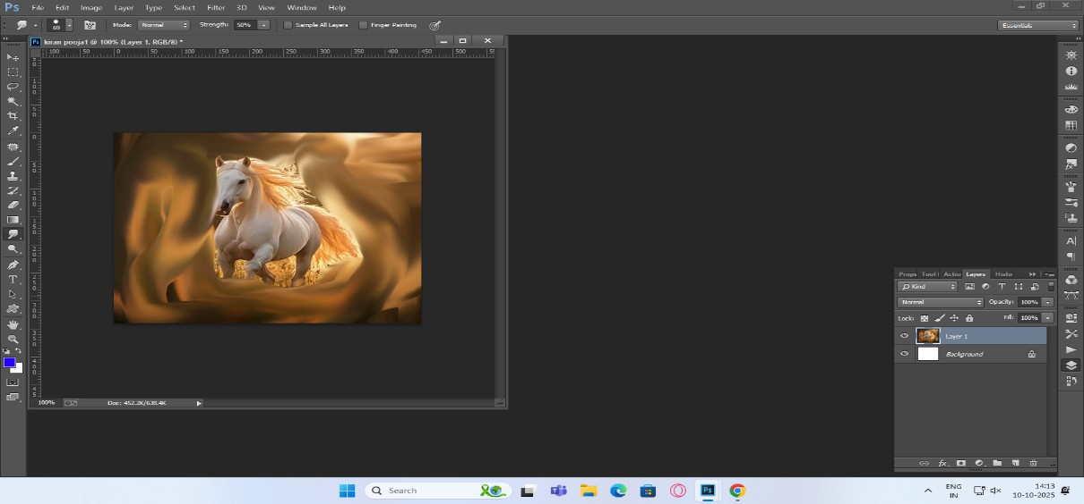

1. **PAINTS WITH PIXELS FROM ANOTHER AREA USING CLONE STAMP TOOL (S)**

**Steps to Use Clone Stamp Tool (S)**

1. **Select the Clone Stamp Tool**

Click the Clone Stamp icon in the toolbar or press S.

1. **Choose Brush Size**

Use the top Options Bar to set brush size and softness.

1. **Select the Source Area**

Hold Alt (Windows) or Option (Mac)

→ Click on the area you want to copy (the source pixels).

1. **Paint on the Target Area**

Move your cursor to the area you want to fix and paint by clicking or dragging.

1. **Repeat if Needed**

Alt/Option-click again to reset a new source and continue cloning.

# SAMPLE OUTPUT:

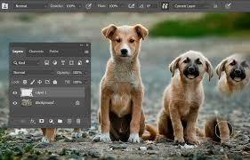

### RESULT

Thus the following Adobe Photo Shop Tools are demonstrated

* Adding text using Type tool
* Make Selections with the Magnetic Lasso Tool
* Replace unwanted content with the patch tool and Apply filter to it
* Work with the smudge tool to smooth and blend colors.
* Blur areas in an image with Blur tool.
* Remove background using eraser tool
* Paints with pixels from another area using Clone Stamp Tool (S)

# EXP.NO:3 DESIGN OBSERVATION FRONT PAGE USING PHOTOSHOP DATE:09.09.25

**AIM**

To design an Observation Notebook Front Page in Adobe Photoshop using text formatting, image insertion, shapes, colors, and alignment tools, similar to the given college template.

# PROCEDURE

Step 1:

Open Adobe Photoshop → Go to File → New → Set page size to A4 (2480 × 3508

px) and set the background color to yellow. Step 2:

Use the Text Tool (T) to type the college details at the top: College Name (Bold, Center aligned)

Accreditation details Address

Adjust font size, alignment, and spacing using the Character Panel. Step 3:

Insert the college logo image using File → Place Embedded.

Resize it using Free Transform (Ctrl + T) and place it at the center of the page. Step 4:

Use the Text Tool (T) again to add the heading “OBSERVATION NOTE-BOOK”

below the logo.

Center align the text and increase the font size. Step 5:

Create the student detail section at the bottom:

Use Text Tool to type labels: NAME, ROLL NO, REG. NO, YEAR, SECTION Draw straight underline lines using the Line Tool (U)

Align labels and lines using the Move Tool (V) to match the given layout. Step 6:

Check the alignment of all text and logo elements.

Save the file as PSD for editing and export final output as JPEG/PDF.

# SAMPLE OUTPUT:



**RESULT:**

Thus the front page of observation note book was designed and created successfully by using photoshop.

# EXP.NO:4 DESIGN OUR COLLEGE LOGO USING PHOTOSHOP. DATE:16.09.25

### AIM

Design Panimalar Engineering College logo using photoshop tools.

### ALGORITHM

#### Step 1: Open a New Document

1. Open Photoshop.
2. Create a new document with the desired dimensions. For example:
   * Width: 1000px
   * Height: 1000px
   * Resolution: 300dpi for high-quality output.

#### Step 2: Plan the Logo Elements

1. Sketch the basic layout of the logo (for example, whether it has text, shapes, or symbols).
2. Determine the colours, shapes, fonts, and design elements that represent the

college’s brand identity.

1. Prepare any symbols, icons, or text needed for the logo (e.g., an emblem, shield, or crest).

#### Step 3: Draw the Base Shape of the Logo

1. Select the Shape Tool (U) from the toolbox.
2. Choose the appropriate shape for your logo base (e.g., circle, square, or shield).
3. Hold the Shift key (for a perfect circle or square) and draw the shape on the canvas.
4. Set the fill colour and stroke to match the primary colour of the logo.

#### Step 4: Create Symbols or Emblems (if applicable)

1. If the logo includes symbols (e.g., a book, torch, or emblem), use the Shape Tool

(U) to draw simple shapes, or use the Pen Tool (P) for custom designs.

1. For a torch symbol, for example, you could combine circles and lines. For a book, you can use rectangles.
2. Position these elements within the logo’s base shape (circle, square, etc.).

#### Step 5: Add Text (College Name or Initials)

1. Select the Text Tool (T).
2. Choose a font that represents the college’s identity (serif, sans-serif, or decorative fonts).
   * For academic institutions, use a strong, professional font.
3. Type the full college name or initials (depending on the logo design).
4. Adjust the font size, style, and colour to match the overall design. Typically, college logos have prominent text, so ensure the text is bold or easily readable.
5. Position the text within the logo shape, either at the top, centre, or bottom, based on your design.

#### Step 6: Apply Gradients or Effects (Optional)

1. If your logo includes gradients, select the shape layer, then:
   * Right-click on the layer and select Blending Options.
   * Choose Gradient Overlay and adjust the colours, style, and angle.
2. For 3D effects or shadows, use the Drop Shadow or Inner Glow under Blending Options to give the logo depth.
3. Experiment with effects to give the logo a unique look (such as embossing, bevel, or outer glow).

#### Step 7: Refine the Logo Layout

1. Use the Move Tool (V) to adjust the position of shapes and text.
2. Use the Align options to ensure all elements are properly cantered or aligned in relation to each other (use the Align toolbar at the top of the workspace).
3. Ensure the logo has a balanced and symmetrical design.

#### Step 8: Add Additional Elements (Optional)

1. If the logo includes a motto or slogan, use the Text Tool (T) to add it in a smaller font size.
2. Place the motto or slogan in a suitable location beneath the main logo.
3. If needed, add decorative elements like lines, borders, or icons to complete the logo.

#### Step 9: Finalize the Logo

1. Zoom in to inspect details and ensure that all elements are sharp and aligned properly.
2. Remove any unwanted layers or extra elements that do not belong in the final design.
3. If you need the logo to be scalable, ensure that it is created using vector shapes and text (instead of pixel-based images).

#### Step 10: Save and Export the Logo

1. Save the project in PSD format to preserve layers for future edits.
2. For final output, export the logo in a suitable format:
   * PNG (for transparency).
   * JPEG (for web use).
   * SVG (for vector graphics, if needed).
3. Use the Save As option in Photoshop and choose the format you need for print, web, or branding use.

# SAMPLE OUTPUT:



**RESULT:**

Thus the college logo was designed and created successfully by using photoshop.

# EXP.NO:4 DESIGN A VISITING CARD USING PHOTOSHOP (FRONT-SIDE DATE:16.09.25 AND BACK-SIDE DESIGN)

### AIM

Design front and back sides of a visiting card of a person who is working in Birla soft solutions Chennai.

### ALGORITHM

#### Start Photoshop

Open Adobe Photoshop and create a new project.

#### Set Document Dimensions

* + Go to File → New.
  + Set dimensions typically used for visiting cards:
* Width: 3.5 inches
* Height: 2 inches
* Resolution: 300 DPI (for high-quality print)
* Colour Mode: CMYK (for print).

#### Create Background Layer

* + Create a new layer named “Background.”
  + Use the Paint Bucket Tool or Gradient Tool to fill the background with a desired colour or gradient.

#### Add a Logo

* + Go to File → Place Embedded and insert the company logo.
  + Position and resize the logo using the Move Tool.

#### Insert Company Name

* + Select the Text Tool (T).
  + Click on the canvas and type the company name.
  + Choose an appropriate font, size, and colour in the text properties panel.
  + Position the text prominently.

#### Add Contact Information

* + Use the Text Tool (T) again to add the following details:
* Name of the individual
* Job title
* Phone number
* Email address
* Website URL and Address
  + Align and format the text neatly.

#### Add Design Elements

* + Use the Shape Tool to add lines, borders, or icons for better visual appeal.
  + Apply shadows or effects using the Blending Options to enhance the design.

#### Align and Adjust Layout

* + Use the Move Tool to adjust the alignment and spacing of all elements.
  + Utilize the Guides and Grids for precise alignment.

#### Review and Finalize Design

* + Check for any spelling errors or misalignment.
  + Ensure that all layers are correctly named and organized.

#### Export the Visiting Card

* Go to File → Export → Export As.
* Choose JPEG or PDF for printing or sharing.
* Save the file with appropriate settings for high-quality output.

1. End

# SAMPLE OUTPUT:

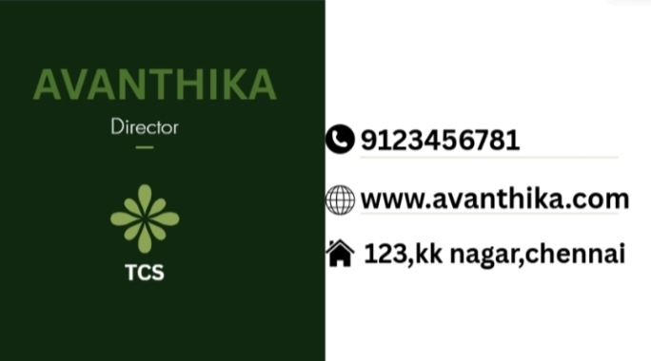



**RESULT:**

Thus the visiting card was designed and created successfully by using photoshop.

# EXP.NO:4 DESIGN A CERTIFICATE FOR AN EVENT USING PHOTOSHOP DATE:23.09.25

**AIM**

To design a professional Event Certificate in Adobe Photoshop using shapes, borders, text formatting, and image insertion tools.

# PROCEDURE

Step 1:

Open Adobe Photoshop → Go to File → New → Create a document of size A4 (2480

× 3508 px) with white background. Step 2:

Use the Rectangle Shape Tool (U) to create an outer border around the page. Adjust stroke thickness and color (blue, gold, or any event theme color).

Step 3:

Insert the event logo / institution logo using File → Place Embedded.

Resize it and place it either at the top center or top-left corner. Step 4:

Use the Text Tool (T) to add the main heading:

"Certificate of Participation" / "Certificate of Achievement"

Increase the font size, center align, and apply layer styles like shadow or emboss if required.

Step 5:

Use the Text Tool (T) again to type the body content:

"This is to certify that has successfully participated in the event

held on ."

Adjust font sizes, line spacing, and alignment. Step 6:

Add signature lines, event coordinator name, organizing head, date, and seal/logo using the Text Tool and Line Tool.

Align everything neatly using the Move Tool (V). Step 7:

Finalize the layout, check alignment, and apply decorative elements such as shapes or patterns if needed.

Save as PSD and export final certificate as JPEG/PDF.

# SAMPLE OUTPUT:

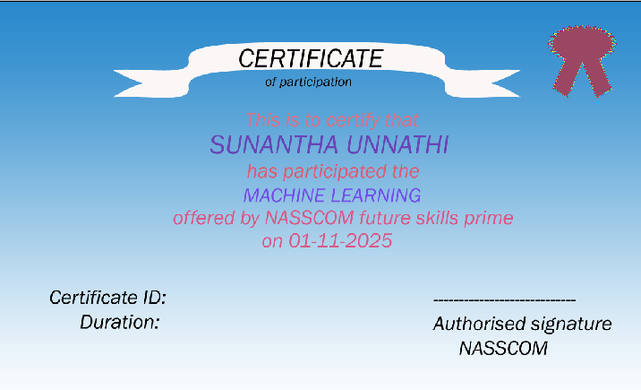

**RESULT:**

Thus, the Event Certificate was successfully designed using Adobe Photoshop by applying borders, text formatting, image insertion, alignment tools, and decorative graphic elements.

# EXP.NO:7 TIMELINE & TRIMMING ADDING, ARRANGING, AND DATE:07.10.25 TRIMMING VIDEO CLIPS, IMAGES, AND AUDIO

**TRACKS USING CANVA TOOLS.**

### AIM

To perform trimming, adding, and arranging audio and video tools in CANVA tool. Create a short film too.

### ALGORITHM

#### Step 1: Create a New Video Project

1. **Open Canva**:
   * Go to [Canva](https://www.canva.com/) and log in to your account.

#### Create a New Design:

* + Click on the Create a designbutton on the top right corner.
  + Select Videofrom the dropdown menu to start a new video project.

#### Step 2: Add Video Clips, Images, and Audio Tracks

1. **Upload Media**:
   * Click on the Uploadstab on the left sidebar.
   * Click on Upload mediaand select the video clips, images, and audio tracks you want to use from your device.

#### Add Media to Timeline:

* + Drag and drop the uploaded video clips, images, and audio tracks onto the timeline at the bottom of the screen.

#### Step 3: Arranging Video Clips and Images

* + - **Arrange Clips and Images**:
* Drag the video clips and images along the timeline to arrange them in the order you want them to appear.

#### Adjust Duration:

* + Click on an image or video clip on the timeline.
  + Drag the edges of the clip to adjust its duration on the timeline.

#### Step 4: Trimming Video Clips

* + - **Select the Clip**:
  + Click on the video clip on the timeline that you want to trim.

#### Trim the Clip:

* + Click on the scissors icon (Trim) that appears on the toolbar above the timeline.
  + Drag the handles on either side of the video clip to trim the start or end of the clip.
  + Click Donewhen you are satisfied with the trim.

#### Step 5: Adding and Arranging Audio Tracks

1. **Add Audio**:
   * Go to the Musictab on the left sidebar to access Canva's music library, or upload your own audio under the Uploadstab.
   * Drag and drop the audio track onto the timeline.

#### Arrange Audio:

* + Drag the audio track along the timeline to sync it with the video clips and images.

#### Adjust Audio Length:

* + Click on the audio track on the timeline.
  + Drag the edges of the audio track to adjust its duration.
  + Trim the audio using the same method as trimming video clips.

#### Step 6: Preview and Fine-Tune

1. **Preview Your Video**:
   * Click the play button above the timeline to preview your video.
   * Make sure the transitions between clips are smooth and the audio is synced correctly.

#### Fine-Tune:

* + Adjust the positions of clips, images, and audio as needed.
  + Use additional tools like transitions, text, and effects to enhance your video.

#### Step 7: Export Your Video

1. **Export**:
   * Once you are satisfied with your video, click on the Downloadbutton in the top right corner.
   * Select the desired video quality and click Downloadto export your video.

# SAMPLE OUTPUT:

**Trim videos online to its right length**

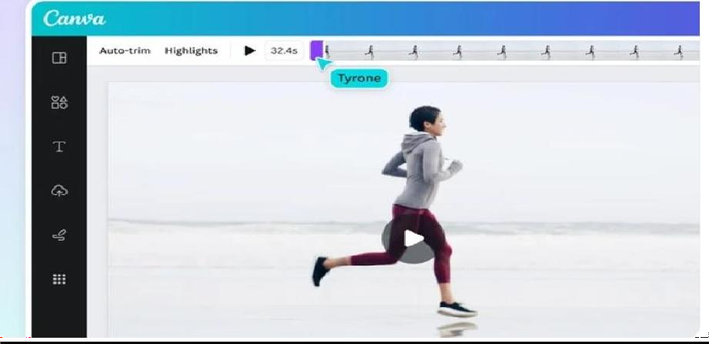

**Add Music To Video: Add Audio, Songs & More | Canva**

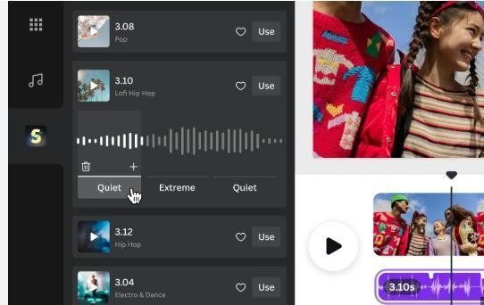

**Split and splice your videos**

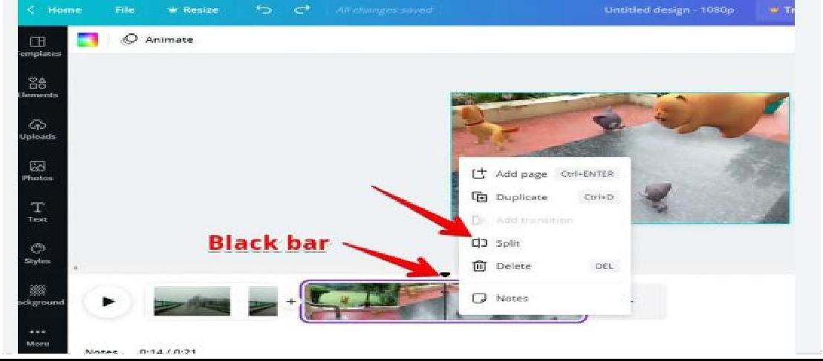

### RESULT

Thus, various audio and video editing operations using CANVA tool are executed and a short film was created.

# EXP.NO:4 DESIGN A POSTER AND RESUME USING CANVA DATE:16.09.25

### AIM

To design a Poster and Resume Using Canva

### ALGORITHM

**STEPS FOR TO DESIGN A POSTER USING CANVA:**

Step 1: Go to Canva's website or open the Canva app. Log in or sign up for a free account if not already done.

Step 2: Choose Template

Search for "Event Poster" or "Banner" in the template search bar. Select a template that matches your theme or event style.

Step 3: Set Dimensions

Click Custom Size if a specific size is needed (e.g., 1080x1920 px for posters). Open the template editor.

Step 4: Add Event Details Use Text Tool to add:

Event Name (e.g., Symposium on AI Innovations). Date, Time, and Venue. Call to Action (e.g., "Register Now" or "Join Us").

Step 5: Customize Design Change Background:

Use a solid color, gradient, or image that complements the event theme. Add Elements: Use shapes, lines, or frames to highlight sections. Upload Images/Logos:

Add the event logo, sponsor logos, or relevant graphics.

Step 6: Enhance Visual Appeal

Use Canva's library to add icons or illustrations (e.g., tech symbols for a symposium). Adjust fonts, colors, and alignments for readability and aesthetics.

Step 7: Finalize the Design

Preview the poster or banner to check for alignment, spelling, and visual balance. Make adjustments if necessary.

Step 8: Save and Export Save the design on Canva.

Download the file in the desired format (e.g., PNG for digital use, PDF for printing).

Step 9: Share or Print

Share the design directly from Canva via email or social media. Print the design if needed for offline use.

# SAMPLE OUTPUT:



STEPS FOR TO CREATE RESUME USING CANVA:

#### Step 1: Open Canva

1. Visit [Canva](https://www.canva.com/) or launch the Canva app.
2. Log in or create an account if you don’t have one.

#### Step 2: Search for Resume Templates

1. Type "Resume" in the search bar.
2. Browse through various templates and select one that matches your style and professional field.

#### Step 3: Set Up the Template

1. Click on the chosen template to open it in the editor.
2. Adjust the layout dimensions if required (e.g., A4 size for standard resumes).

#### Step 4: Add Personal Details

1. Replace placeholder text with your:
   * Full Name.
   * Contact Information (email, phone number, LinkedIn profile, etc.).
   * Professional Photo (optional but preferred in certain industries).

#### Step 5: Add Career Objective

1. Write a concise career objective or professional summary highlighting your goals and skills.

#### Step 6: Fill in Education Details

1. Add your educational qualifications in reverse chronological order:
   * Degree, Institution, Year of Graduation, and Key Achievements.

#### Step 7: Add Work Experience

1. List your work experience in reverse chronological order:
   * Job Title, Company Name, Duration, and Key Responsibilities.
2. Use bullet points to describe achievements clearly.

#### Step 8: Highlight Skills

1. Use icons or sections to list both technical and soft skills relevant to your field.
2. Include proficiency levels (e.g., Beginner, Intermediate, Expert).

#### Step 9: Add Certifications and Achievements

1. Create a separate section for certifications (e.g., "AWS Certified Solutions Architect").
2. Mention relevant awards or achievements.

#### Step 10: Customize Design

1. Adjust colours, fonts, and alignments for consistency and readability.
2. Replace icons or visuals to align with your profession (e.g., tech symbols for IT).

#### Step 11: Proofread and Finalize

1. Check for grammatical errors, formatting issues, and typos.
2. Preview the resume to ensure all information is accurate and visually appealing.

#### Step 12: Download the Resume

1. Save your design on Canva.
2. Download the resume in a professional format like PDF.

#### Step 13: Share or Print

1. Share the resume digitally or print it for physical applications.

# SAMPLE OUTPUT:

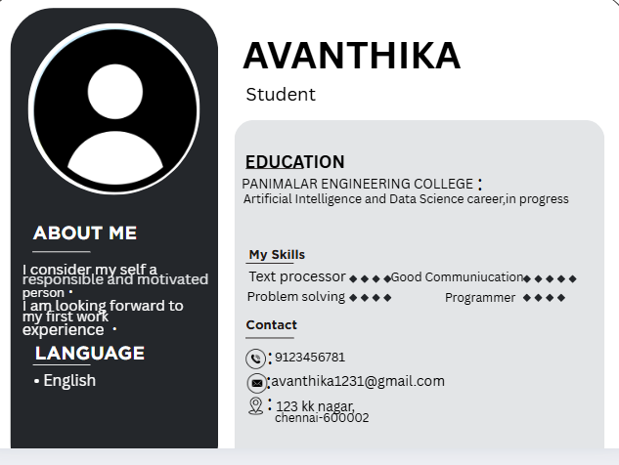

**RESULT:**

Thus the poster and resume was prepared in a professional way using Canva tools.

# EXP.NO:9 CREATE LINKEDIN PROFILE AND UPLOAD DATE:14.10.25 RELEVANT CERTIFICATIONS.

### AIM

Create LinkedIn profile of the individual candidate and upload online certificates in your LinkedIn profile to showcase your professional achievements. (4 online certification courses must be completed in order to upload in LinkedIn profile)

### ALGORITHM

#### Step 1: Visit LinkedIn

Open LinkedIn or download the LinkedIn app. Sign up or log in if you already have an account.

#### Step 2: Complete Basic Profile Details

Enter your Name, Email, and Password to create an account. Add your location, job role, or select Student.

Confirm your email to verify the account.

#### Step 3: Build Your Profile

Upload a professional profile photo.

Write a headline summarizing your expertise (e.g., "Software Engineer | Certified AWS Developer"). Add an About Section to introduce yourself, highlighting skills and career objectives.

#### Step 4: Add Certifications

Go to the Licenses & Certifications section in your profile. Click Add Certification and enter: Certification Name (e.g., "AWS Certified Solutions Architect"). Issuing Organization (e.g., "Amazon Web Services").

Issue and Expiry Dates (if applicable).

Credential ID and URL (optional but recommended). Repeat for all relevant certifications.

#### Step 5: Add Other Sections

Fill in Work Experience with job roles, responsibilities, and achievements. Add Education with details of institutions, degrees, and years.

Include Skills related to your field and get endorsements from connections.

#### Step 6: Customize Profile

Edit your LinkedIn URL for a professional touch (e.g., linkedin.com/in/yourname). Add a banner image related to your profession or achievements.

#### Step 7: Connect with Professionals

Search for colleagues, mentors, or peers and send connection requests. Join relevant LinkedIn groups to expand your network.

#### Step 8: Share and Engage

Share updates about your certifications and achievements. Comment on and engage with posts in your domain**.**

### SAMPLE OUTPUT:

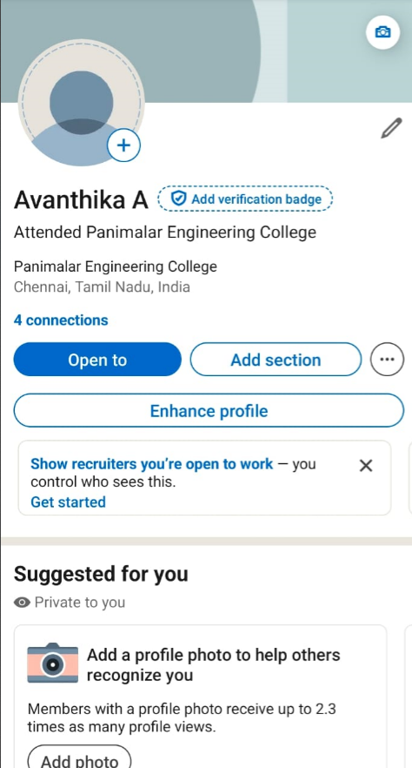

**RESULT:**

Thus, my LinkedIn profile was created and online course certifications are uploaded in my LinkedIn profile.

# EXP.NO:10 LEARNING BASICS OF CHATGPT DATE:14.10.25

**AIM**

To learn the basic tools of ChatGPT and practice giving text-based inputs to the model

while clearly expressing what you want it to find or generate.

# ALGORITHM

#### Step 1: Understanding ChatGPT

1. **Definition**

ChatGPT is an AI language model created by OpenAI that generates human-like text based on

the user’s input.

#### Capabilities

It can answer questions, explain concepts, create content, translate languages, summarize text, and more.

#### Purpose

Supports learning, research, creativity, programming, and problem-solving through natural language.

#### Interaction Style

Works through conversational text where you type and receive responses.

#### Output Variety

ChatGPT can produce informative, creative, technical, or step-based responses depending on your request.

#### Step 2: Accessing ChatGPT

1. **Platforms**

You can use ChatGPT through OpenAI’s website, supported apps, third-party chatbots, or API integrations.

#### Account Requirement

Some platforms may require you to log in or create an account.

#### Device Compatibility

Accessible on computers, tablets, or mobile phones.

#### Internet Access

A stable internet connection is required for using the service.

#### Interface Overview

* + Typically includes a chat window and a text input box for entering prompts.

#### Step 3: Providing Text to ChatGPT

1. **Starting a Session**

Open the ChatGPT interface on your chosen platform.

#### Entering Your Query

Type your question or instruction clearly in the input box.

#### Being Specific

Write a focused prompt to get accurate results.

*Example:* “What are the benefits of regular exercise?”

#### Task Orientation

You may ask for definitions, summaries, explanations, or creative responses.

#### Submission

Press send/enter to receive the model’s response.

#### Step 4: Telling ChatGPT What You’re Looking For

1. **State Your Requirement Clearly**

Mention exactly what output you expect.

*Example:* “Give me a short summary of the benefits of regular exercise.”

**Add Context When Needed**

Provide background if the task is detailed or specific.

*Example:* “I need the summary for a presentation. Keep it short and informative.”

#### Tone or Format Preference

You can request a tone such as formal, simple, friendly, or professional.

#### Output Length

Specify if you need a short list, paragraph, or long explanation.

#### Purpose

Mention why you need it to help ChatGPT tailor the response.

#### Step 5: Refining and Interacting

1. **Review the Output**

Read the response carefully to see if it meets your requirements.

#### Ask Follow-ups

Request additional details or ask for a revised version.

*Example:* “Can you list only the mental health benefits?”

#### Clarify Needs

If the answer is too general, ask ChatGPT to be more specific.

#### Try Rewriting

Ask the model to rephrase or restructure the response.

#### Iterative Improvement

Continue adjusting prompts until you receive the desired output.

#### Step 6: Performing Specific Tasks with ChatGPT

1. **Text Generation**

Ask ChatGPT to write essays, emails, speeches, stories, etc.

*Example:* “Write a motivational speech on perseverance.”

#### Summarization

Paste a passage and ask for a brief summary.

*Example:* “Summarize this article on climate change in 100 words.”

#### Direct Answers

Ask factual questions.

*Example:* “What is the capital of France?”

#### Explanations

Request simplified or technical explanations.

*Example:* “Explain the theory of relativity in simple words.”

#### Problem Solving

Ask for steps, procedures, or methods for various tasks.

#### Step 7: Using Advanced Features

1. **Custom Response Style**

In certain platforms, you can control tone, length, and structure.

*Example:* “Explain the benefits of exercise in a professional tone.”

#### API Integration

Developers can use the OpenAI API to embed ChatGPT into applications.

#### Automation

ChatGPT can automate writing, summarizing, or analysis tasks.

#### Plugins / Tools (if available)

Some versions support browsing, file handling, or code interpretation.

#### Multi-step Workflows

You can guide ChatGPT through complex, multi-part tasks.

#### Step 8: Practice and Experiment

1. **Regular Usage**

Frequent interaction helps you understand how to frame better prompts.

#### Try Different Prompt Styles

Experiment with questions, descriptions, instructions, and creative prompts.

#### Evaluate Responses

Compare how different prompts produce different results.

#### Explore Capabilities

Test summarization, translation, idea generation, and more.

#### Learn Limitations

Understand what ChatGPT can and cannot do to improve efficiency.

**SAMPLE OUTPUT:**

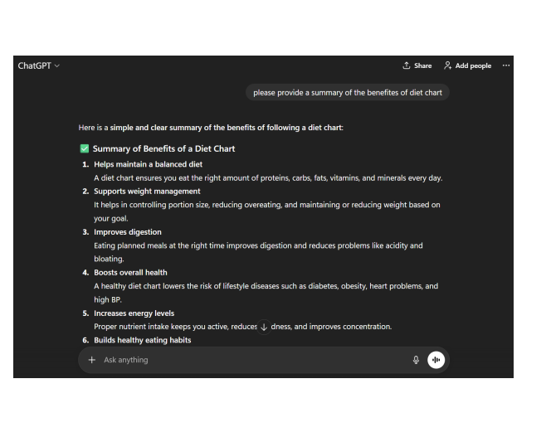

RESULT:

Thus, the basic usage of ChatGPT was learned successfully, and various prompts were tested to observe how the model responds.

# EXP.NO:11 PROMPT ENGINEERING DATE:28.10.25

**AIM**

To explore how ChatGPT responds to various types of prompts. Students will experiment with questions, conversations, and incomplete statements to understand how prompt style influences AI outputs.

# PROCEDURE:

## Example Prompt:

"You are a knowledgeable AI. Please answer the following question: What is the capital of England?"

## Prompt Engineering

Prompt engineering is the process of crafting and refining the input text (prompt) provided to an AI model like ChatGPT. It helps generate accurate, meaningful, and creative responses. As AI becomes an essential part of modern technology, prompt engineering has emerged as an important skill for achieving precise results from AI systems.

This concept focuses on understanding how to guide the model effectively by giving clear instructions, defining context, and specifying the desired output.

## Example:

Poor prompt: “Write something about AI.”

Improved prompt: “Write a 100-word paragraph explaining AI to high school

students.”

## Uses of Prompt Engineering

* Enhances the quality of AI-generated responses.
* Helps obtain focused and specific output.
* Supports tasks like chatbots, programming assistance, and content creation.

## What are Prompts?

Prompts are short text inputs that provide context or instructions to an AI model. In natural language processing (NLP), prompts guide models to generate responses

aligned with the user’s intent.

## Prompts help by:

* Giving clear direction to the model.
* Avoiding overly general input.
* Preventing excess or confusing information.
* Clarifying the purpose and context of the task.

**Importance of prompt engineering:**

* Well-structured prompts improve the model’s understanding of task requirements.
* Detailed instructions help generate output closer to the expected result.
* Effective prompts lead to better performance in NLP applications and provide improved training patterns for future tasks.

# TYPES OF PROMPTS WITH EXAMPLES

## Direct Questions Factual:

* “What is the capital of Japan?”
* “Who wrote Pride and Prejudice?”

## Conceptual:

* “Explain the theory of evolution.”
* “What causes climate change?”

## Conversation Starters Casual:

* “Hi! How is your day going?”
* “What are the latest technology trends?”

## Debates:

* “Has technology improved our lives or complicated them?”
* “Which is better—working from home or office?”

## Incomplete Sentences

* “The most important quality in a leader is…”
* “If I could visit any place in the world, I would go to…”

## Creative Writing Prompts Story:

* “Once upon a time, in a distant land…”
* “The spaceship landed on an unknown planet. The first thing they noticed was…”

## Poetry:

* “Write a poem about the changing seasons.”
* “Create a haiku on the ocean.”

## Instruction / How-To Prompts

* “How do I bake a chocolate cake?”
* “Explain how to set up a home Wi-Fi network.”

## Opinion-Based Prompts Preferences:

* “Which book do you like the most, and why?”
* “Do you prefer cats or dogs?”

## Hypothetical:

* “If you had a superpower, what would it be?”
* “If you were president for one day, what would you change first?”

## Summarization / Paraphrasing Summarization:

* “Summarize the plot of To Kill a Mockingbird.”
* “Summarize the main ideas of the climate change article.”

## Paraphrasing:

* “Paraphrase: ‘The quick brown fox jumps over the lazy dog.’”
* “Rewrite this paragraph in simpler words.”

## Translation

* “Translate this to French: ‘Good morning, how are you?’”
* “How do you say ‘thank you’ in Japanese?”

## Technical and Academic Prompts Technical:

* “Differentiate between HTTP and HTTPS.”
* “What is blockchain and how does it work?”

## Academic:

* “What are the themes in Shakespeare’s Hamlet?”
* “Explain how the Industrial Revolution changed society.”

## Experimenting with Prompts

Try changing your prompts to observe differences in ChatGPT's responses.

## Varying Detail

Simple: “Tell me about photosynthesis.”

Detailed: “Describe photosynthesis with roles of chlorophyll, sunlight, CO₂, and water.”

## Creative vs Informative

Creative: “Write a story about a magical forest.”

Informative: “List the components of a healthy ecosystem.”

## Open-Ended vs Specific

Open-ended: “What do you think about artificial intelligence?” Specific: “What are the ethical issues of using AI in healthcare?”

## Tips for Effective Prompt Engineering

**Clarity:** Write clear and easy-to-understand prompts. **Specificity:** The more precise the prompt, the better the result. **Context:** Give enough background for complex tasks.

**Iteration:** Keep refining your prompt until the output meets your needs.

# SAMPLE OUTPUT:

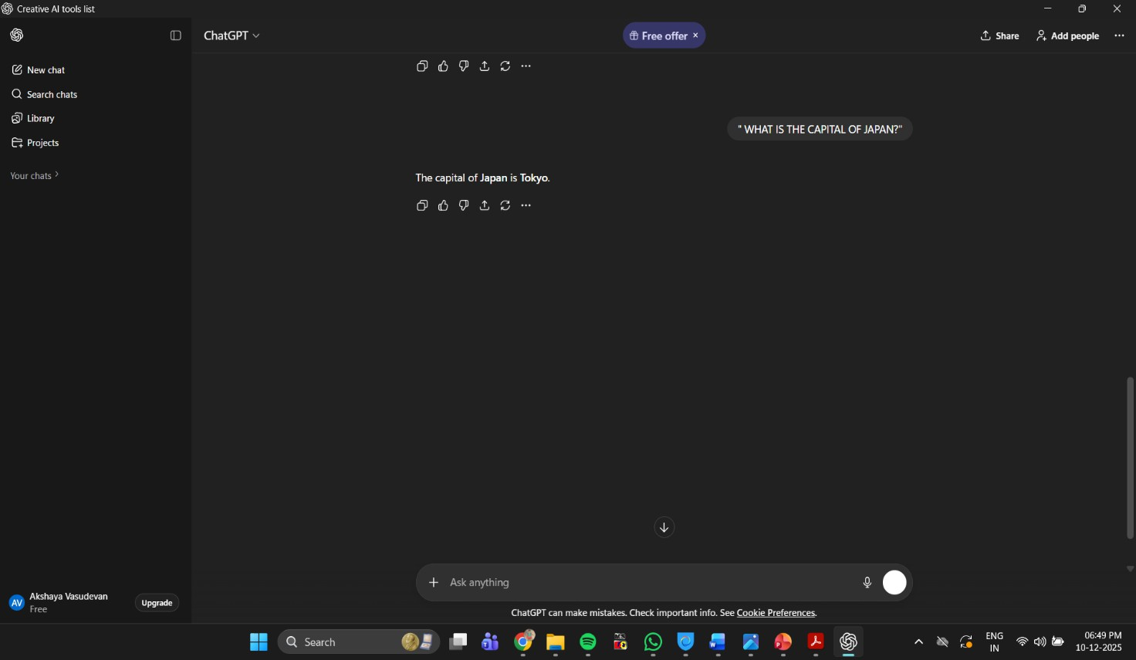

### RESULT:

Thus, the principles of prompt engineering were understood and successfully applied.

# EXP.NO:12 CREATIVE WRITING USING CHATGPT DATE:28.10.25

### AIM

To develop creative writing skills by using ChatGPT to generate ideas, improve narratives, and enhance imagination through AI-assisted writing.

### PROCEDURE

1. Open ChatGPT in your browser.
2. Decide the type of creative writing you want (story, poem, dialogue, script, essay, etc.).
3. Write a clear prompt to ChatGPT describing:

* Theme or topic
* Characters (optional)
* Tone or style
* Length

1. Ask ChatGPT to generate a draft.
2. Review the output and refine it by asking:

* “Make it shorter/longer.”
* “Change tone to funny/sad/adventurous.”
* “Add more emotions/characters.”

1. Edit the final content for personal creativity and originality.
2. Save or present the final creative piece.

### SAMPLE EXAMPLE

#### Prompt given to ChatGPT:

“Write a short story about a magical pen that can change the future.”

#### ChatGPT Output (Story):

A young girl named Meera found a glowing pen in her school library. Whatever she wrote with it became real the next day. At first she used it to help friends—better grades, sunny picnics, and repaired friendships. But when she tried to change her own future too much, the pen stopped glowing. It taught her that the future should be shaped by effort, not shortcuts.

Meera kept the pen safely as a reminder that real magic lies in hard work.

### SAMPLE OUTPUT:

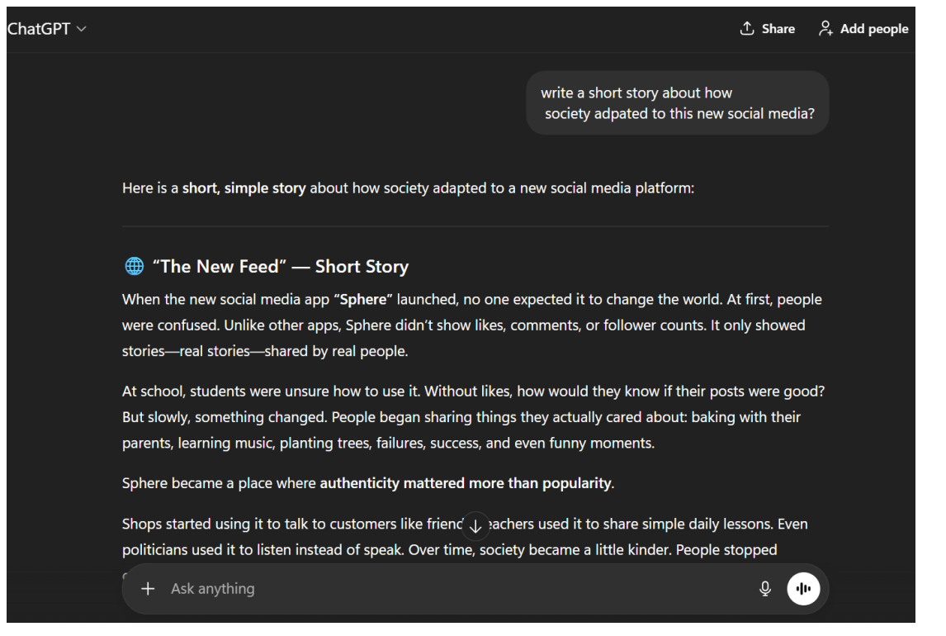

**RESULT:**

Thus, **creative writing using ChatGPT was successfully learned**, and the student understood how to generate ideas, improve content, and create engaging stories with AI assistance.

# EXP.NO:13 SETTING A GIT REPOSITORY AND CREATE A DATE:11.11.25 REPOSITORY IN A GITHUB FOR A TEAM GIT AND

**GITHUB**

### AIM

To create a local Git repository and set up a remote repository on GitHub for team collaboration.

### INTRODUCTION

Git is a version control tool used to track changes in code and manage collaborative development. A GitHub repository (commonly called a **repo**) is an online storage space where project files and their revision history are maintained. It uses Git to record changes, manage versions, and allow multiple developers to work together efficiently.

#### Key Features of a GitHub Repository

1. **Version Control:** Records all changes, enabling you to review or revert to previous versions when necessary.
2. **Collaboration:** Allows multiple developers to work on the same project. Contributors can fork, edit, and submit pull requests.
3. **Branches:** Supports independent development lines for features, bug fixes, or experiments which can later be merged into the main branch.
4. **Issues:** Used for tracking bugs, feature enhancements, and general project tasks.
5. **Pull Requests:** Enables code review and discussion before integrating changes into the main branch.
6. **GitHub Actions:** Automates tasks such as running tests or deploying code directly from the repository.

### ALGORITHM

#### Step 1: Install and Configure Git

1. **Install Git**

Download and install Git (e.g., Git for Windows).

#### Configure Git

Open a terminal or command prompt and set your username and email:

git config --global user.name "Your Name"

git config --global user.email ["your-email@example.com](mailto:your-email@example.com)"

#### Step 2: Create a GitHub Repository

1. **Sign In to GitHub:** Log in to your GitHub account or create one if you don't have it.

#### Create a New Repository:

* + Click the **“+”** icon → **New repository**
  + Enter the repository name and optional description
  + Choose **public** or **private** visibility
  + Optionally initialize with a README
  + Click **Create repository**

#### Step 3: Set Up the Repository Locally

1. **Clone the Repository:**

Navigate to your desired folder and run:

git clone https://github.com/your-username/your-repository.git

Replace *your-username* and *your-repository* with actual details.

#### Enter the Repository Folder:

cd your-repository

#### Step 4: Add Team Members

1. Open your repository on GitHub.

#### Go to Settings → Collaborators & teams.

1. Click **Invite a collaborator**, enter their GitHub username or email, and send the invitation.

#### Step 5: Collaborate Using Git

* + **Make Changes:** Create or edit files in your local repo.

#### Stage Changes:

git add .

#### Commit Changes:

git commit -m "Your commit message"

#### Push to GitHub:

git push origin main

*(Replace main if your default branch has another name.)*

* + **Pull Latest Changes:** git pull origin main **Additional Tips**

#### Branching:

Create separate branches for features or fixes:

git checkout -b feature-branch

#### Merging:

git checkout main

git merge feature-branch

#### Handling Conflicts:

If Git reports merge conflicts, manually edit the files to resolve differences.

# SAMPLE OUTPUT:

**Set up Github repository** - signup in github.com and create a new repository

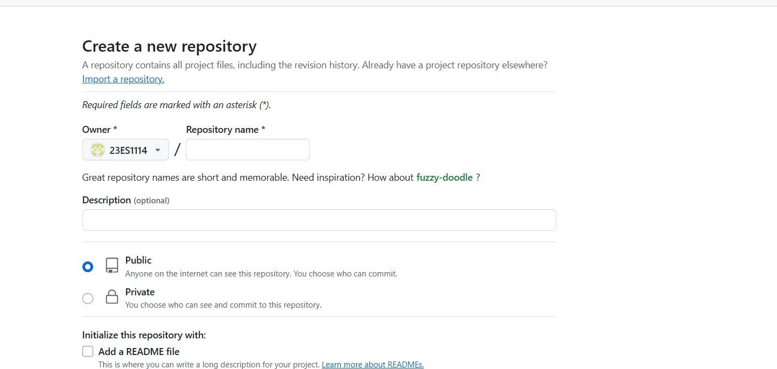

**create a remote repository in github**

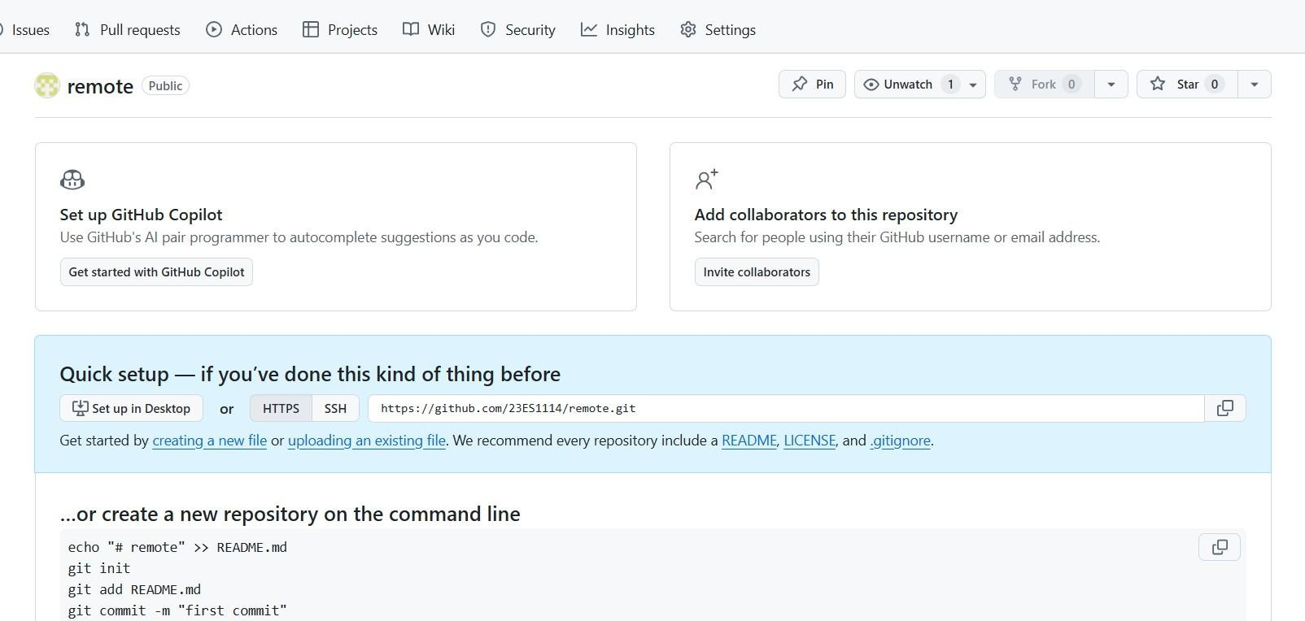

**create a file called HELLO.txt**

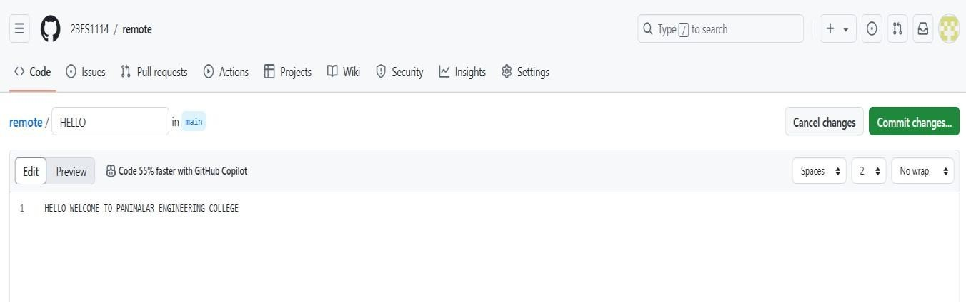

**commit changes**

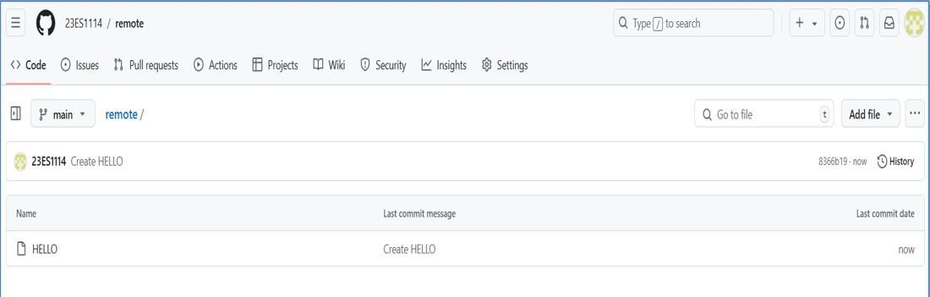

**Setup Git repository in your local system**

Download git in your local system

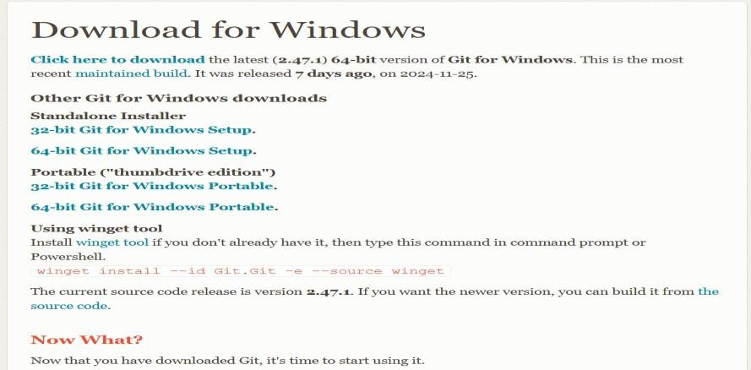

**PANIMALAR ENGINEERING COLLEGE DEPARTMENT OF ARTIFICIAL INTELLIGENCE AND DATA SCIENCE**

#### Now type the following commands //means comment statement

$ git init //Initialize empty Git repository in C:/Users/abcd/.git/

$ git version ‘/git version 2.47.1.windows.1

$ git config --global user.name "23ES1114"

$ git config --global user.mail “[innovativepractice966@gmail.com](mailto:innovativepractice966@gmail.com)”

$ cd git //open C drive, where git directory already created

$ git clone https://github.com/23ES1114/remote.git Cloning into 'remote'...

remote: Enumerating objects: 3, done. remote: Counting objects: 100% (3/3), done.

remote: Total 3 (delta 0), reused 0 (delta 0), pack-reused 0 (from 0) Receiving objects: 100% (3/3), done.

$ dir

#### remote

$ cd remote

$ dir //Notice a file “HELLO.txt” in remote repository is copied in local repository

#### HELLO.txt

Now create a file called WELCOME.txt in the local Git repository

#### $ dir

HELLO WELCOME.txt

**$ git fetch** // it downloads commits, files from a remote repository to local repository

**$ git status //**provides a summary of the current state of your Git repository.

#### output

On branch main

Your branch is up to date with 'origin/main'. Untracked files:

(use "git add <file>..." to include in what will be committed)

WELCOME.txt

nothing added to commit but untracked files present (use "git add" to track)

$ git add WELCOME.txt //adds new files in your working directory to the Git staging area.

$ git commit -m "save" //you can use any word instead of save

#### output

[main 36b4654] save

1 file changed, 1 insertion(+)

create mode 100644 WELCOME.txt

**PANIMALAR ENGINEERING COLLEGE DEPARTMENT OF ARTIFICIAL INTELLIGENCE AND DATA SCIENCE**

#### git push command

is used to **upload your local repository content to a remote repository**. It //transfers commits from your local branch to a corresponding branch on the remote

#### now type

$ git push origin main

Now we can notice the WELCOME.txt is uploaded in remote repository

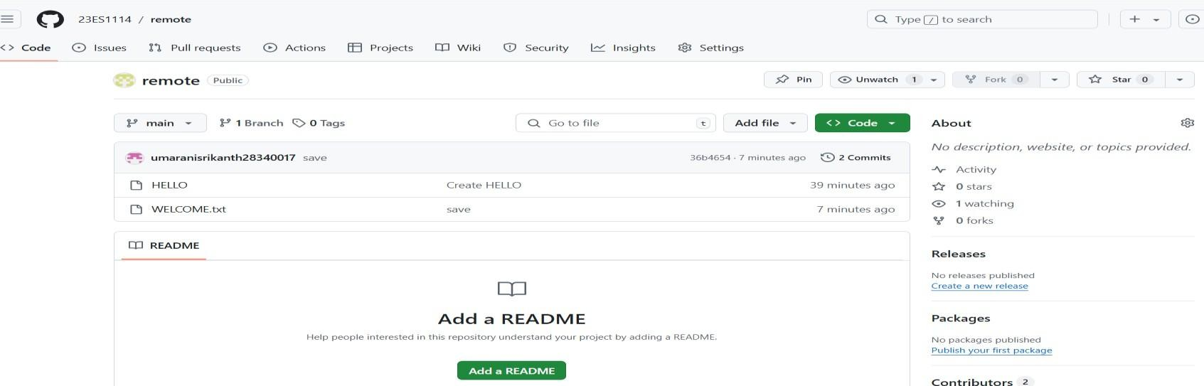

-

create a new text file named “INDIA” in github

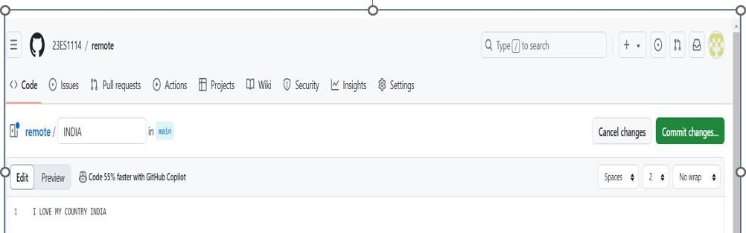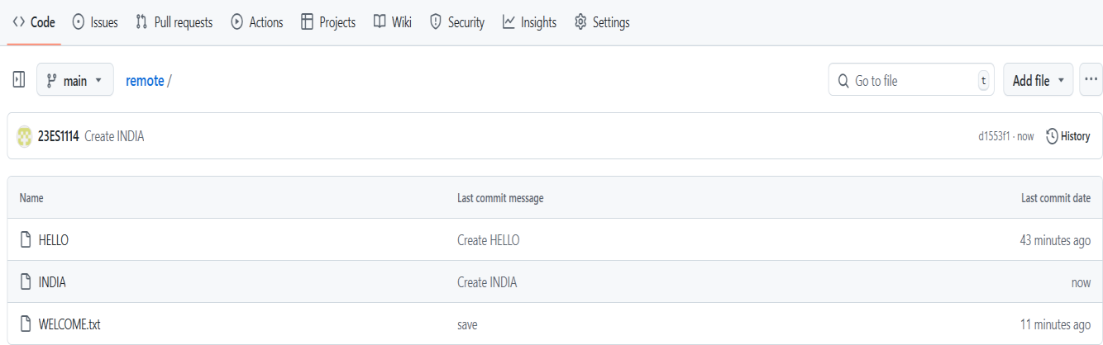

commit the file named INDIA

**git pull command**

downloads new code from the branch named master on the remote named origin and integrates them into your local HEAD branch

#### $ git pull origin main output

remote: Enumerating objects: 4, done. remote: Counting objects: 100% (4/4), done.

remote: Compressing objects: 100% (2/2), done.

remote: Total 3 (delta 0), reused 0 (delta 0), pack-reused 0 (from 0) Unpacking objects: 100% (3/3), 971 bytes | 69.00 KiB/s, done.

From https://github.com/23ES1114/remote

* branch main -> FETCH_HEAD 36b4654..d1553f1 main -> origin/main

Updating 36b4654..d1553f1 Fast-forward

INDIA | 1 +-

1 file changed, 1 insertion(+) create mode 100644 INDIA

#### $ dir

HELLO INDIA WELCOME.txt

Now we could find the file INDIA found in local repository.

# RESULT:

Thus, GIT repository and repository in a GitHub for a team have been implemented and executed successfully.

# EXP.NO:14 CNC PROGRAMMING FOR CNC LATHE AND DATE:18.11.25 MILLING .

To demonstrate CNC programming for CNC lathe and Milling machines.

**Equipment’s Required:** CNC TRAIN software and CNC machines

### ALGORITHM

The different steps involved in using the CNC TRAIN software are as follows:

#### Step 1: Click Start menu -

Programs - CNC simulation - CNCTRAIN (or) Double click icon on the desktop

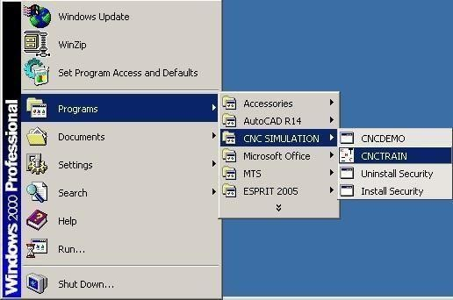

#### Step 2: Selection of controller type

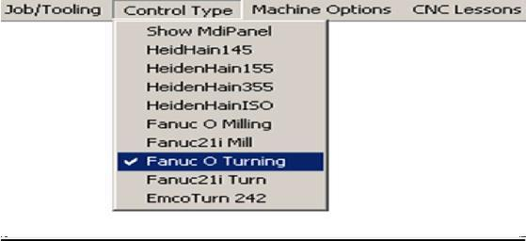

Click Control Type

#### Step 3: Write a new program.

Click file on the main menu and click new CNC program and type the program in the CNC editor screen.

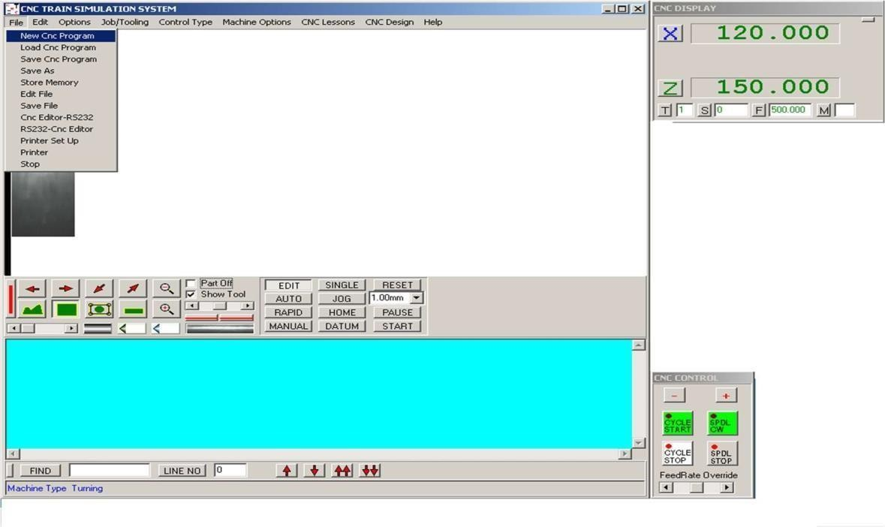

Click file on the main menu and click new CNC program and Type the program in the CNC editor screen.

#### Step 4: Simulation

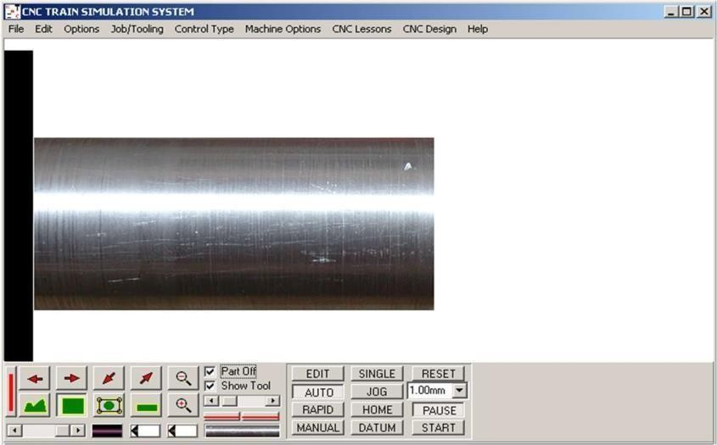

Step 1 Click Auto Step 2: RESET

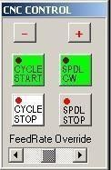

Step 3 Click Cycle start

**Observations:** Carry out the simulations of the following parts in CNC TRAIN software.

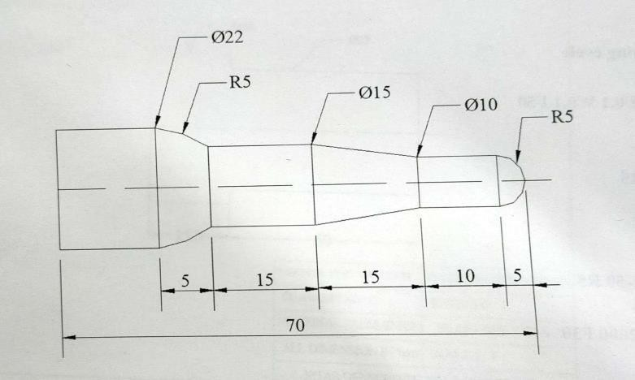

Turning Exercise

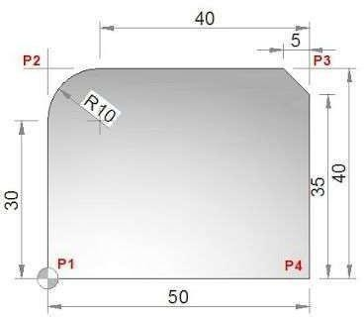

Milling Exercise

### RESULT

Thus, CNC programming for CNC Lathe and Milling was demonstrated.

# EXP.NO:15 3D PRINTING USING FUSION 360 DATE:18.11.25

### AIM

Design of 3D printing using Fusion 360 and product development.

### ALGORITHM

#### Step 1: Design Conceptualization

1. **Sketching**: Begin by sketching out your design idea. Fusion 360 provides a robust sketching environment where you can create 2D profiles that will later be extruded or revolved into 3D shapes.
2. **Constraints and Dimensions**: Use dimensions and constraints to define the size and relationships between different parts of your design. This ensures accuracy and helps in making modifications later.

#### Step 2: 3D Modeling

1. **Extrusion and Revolve**: Use extrusion to give thickness to your 2D sketches, or use revolve to create solid bodies by rotating a sketch profile around an axis.
2. **Boolean Operations**: Combine multiple bodies using Boolean operations (union, subtract, intersect) to create complex shapes.
3. **Fillets and Chamfers**: Add fillets (rounded edges) or chamfers (beveled edges) to your model to improve aesthetics and functionality.
4. **Holes and Threads**: Include holes and threads as needed for assembly or functional requirements.

#### Step 3: Prepare for 3D Printing

1. **Check Geometry**: Ensure there are no gaps or intersecting geometry that could cause issues during printing.
2. **Mesh Preparation**: Fusion 360 has tools to convert your solid model into a mesh suitable for 3D printing. Use the "Mesh" workspace to refine the mesh if needed.
3. **Orientation and Supports**: Decide on the orientation of your model for printing. Consider where supports might be needed and how they will be generated.
4. **Export**: Export your model as an STL file, which is the standard file format for 3D printing.

#### Step 4: Printing

1. **Slicing**: Use slicing software (e.g., Cura, PrusaSlicer) to convert the STL file into G- code, which the 3D printer understands.
2. **Printer Settings**: Configure settings such as layer height, infill density, and print speed based on your design requirements and the capabilities of your printer.
3. **Print**: Start the printing process and monitor the progress to ensure everything is going smoothly.

#### Step 5: Post-Processing

1. **Support Removal**: After printing, carefully remove any support structures.
2. **Surface Finishing**: Depending on your design, you may need to sand, polish, or paint the printed object to achieve the desired finish.
3. **Assembly (if applicable)**: If your design consists of multiple parts, assemble them

according to your design specifications.

**SAMPLE OUTPUT:**

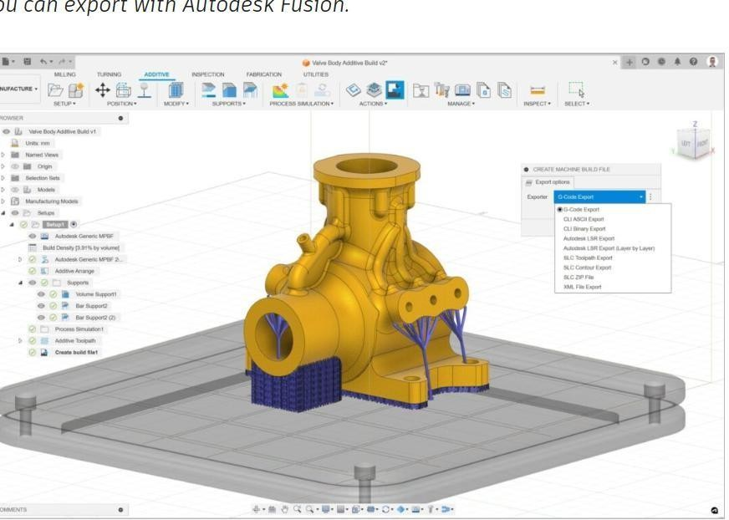

**RESULT**

Thus, design of 3D printing was implemented using Fusion 360 for product development.

# EXP.NO:16 CNC ROUTER FOR ARTCAM SOFTWARE DATE:25.11.25

### AIM

Create the design for CNC router using ArtCAM software.

### ALGORITHM:

#### Step 1: Design Conceptualization

1. **Sketch or Import Design**: Begin by sketching out your design idea or importing a vector-based design into ArtCAM. ArtCAM supports importing various file formats such as DXF, DWG, AI, EPS, etc.
2. **Define Toolpaths**: Decide on the toolpaths you'll use for machining. This includes roughing, finishing, and any additional operations like drilling or pocketing.

#### Step 2: Setting Up the Project

1. **Material and Dimensions**: Specify the material type and dimensions in ArtCAM. This affects how the toolpaths are generated and the overall machining process.
2. **Layer Management**: Organize your design into layers within ArtCAM. This helps in managing different components of the design and assigning toolpaths accordingly.

#### Step 3: Design Tools in ArtCAM

1. **Vector Creation**: Use ArtCAM’s drawing tools to create or modify vectors as needed. Vectors define the toolpath for the CNC router.
2. **Relief Creation**: ArtCAM allows you to create 3D reliefs from 2D vectors. This is useful for adding depth and detail to your design.
3. **Texture and Inlays**: Explore ArtCAM’s texture and inlay features if you want to add surface textures or combine different materials in your design.

#### Step 4: Toolpath Creation

1. **Roughing Toolpath**: Set up roughing toolpaths to remove excess material efficiently. Adjust parameters such as stepover and cutting depths based on your material and desired finish.
2. **Finishing Toolpath**: Create finishing toolpaths to achieve the final surface quality. Fine-tune parameters like stepover and tool diameter for precision.
3. **Drilling and Pocketing**: If your design requires holes or pockets, set up drilling and pocketing toolpaths accordingly.

#### Step 5: Simulation and Verification

1. **Simulation**: Use ArtCAM’s simulation tools to preview how the CNC router will machine your design. This helps in detecting any issues such as collisions or inefficient toolpaths.
2. **Verification**: Verify toolpaths and ensure they are correctly set up to achieve the desired result. Check feeds, speeds, and tool clearances to avoid errors during machining.

#### Step 6: Exporting Toolpaths

1. **Toolpath Export**: Once satisfied with the toolpaths, export them in a compatible format (e.g., G-code) that your CNC router can understand.

#### Step 7: Machining

1. **Set Up CNC Router**: Load the exported toolpaths into your CNC router’s control software. Follow manufacturer guidelines for tool and material setup.
2. **Machining Process**: Start the machining process, ensuring proper tool alignment and feed rates. Monitor the machining to ensure it progresses as expected.

a) ArtCAM fast start and running

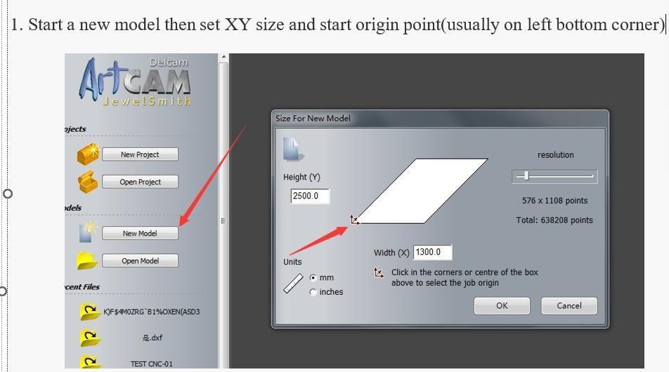

1. Draw any shape and edit the size and position by click transform

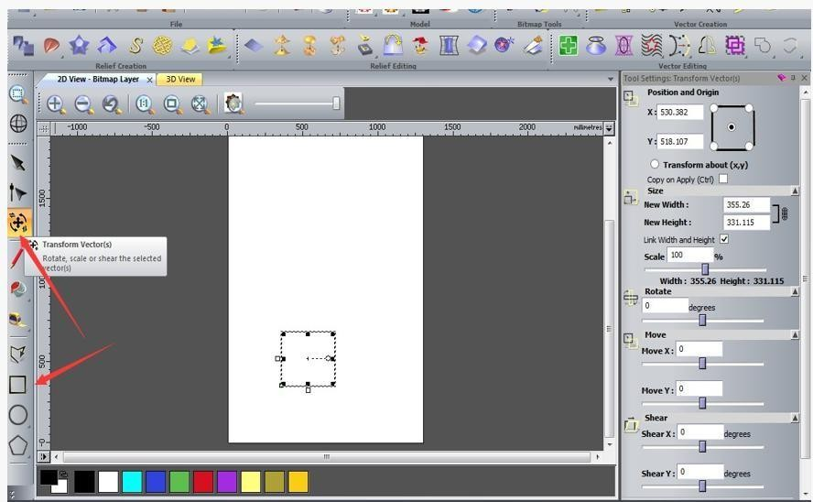

1. Edit the position to start point by picture shows below and the size as well.

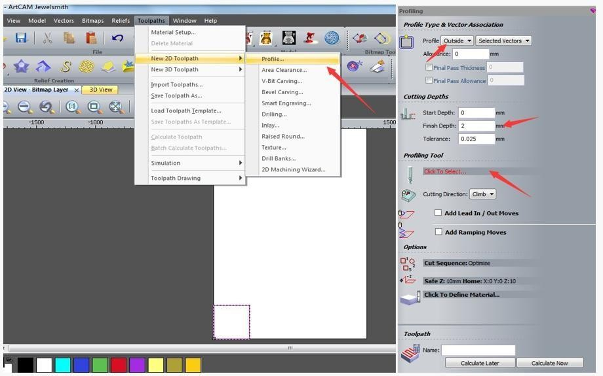

1. Choose the vector and click toolpaths - 2D toolpath - profile and edit the parameters

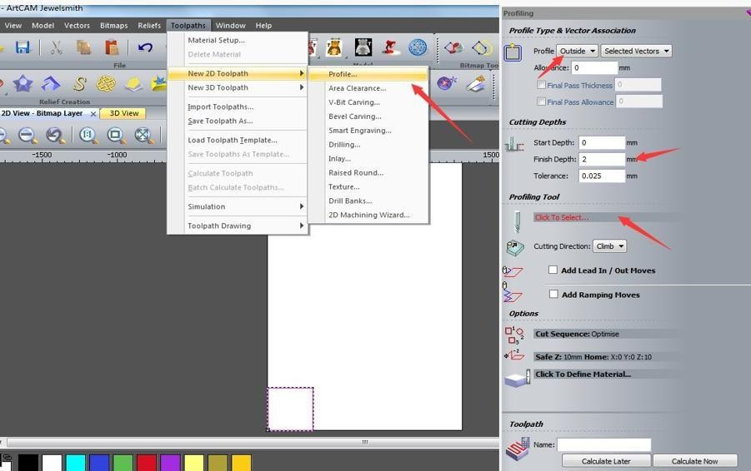

1. Choose the tool you will need to use then edit the speed and step down. During test run on [**CNC**](https://www.acctekgroup.com/cnc-router/)[**router**,](https://www.acctekgroup.com/cnc-router/) suggest choose spindle speed 18000 and feedrate 4000mm/min, plunge rate 1000. Calculate the toolpath and save.

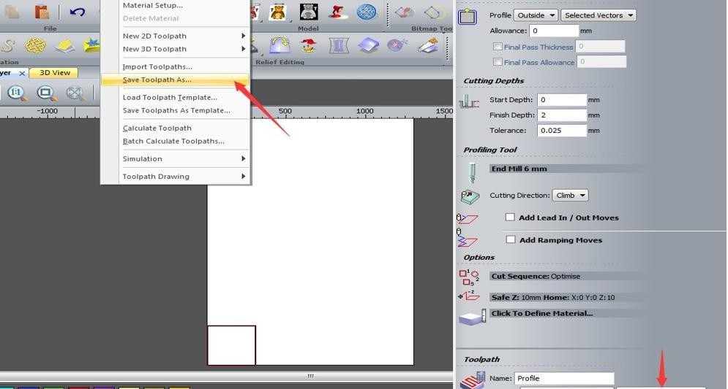

1. Choose a post processor and save the gcode, usually choose tap.mmg.nc.cnc

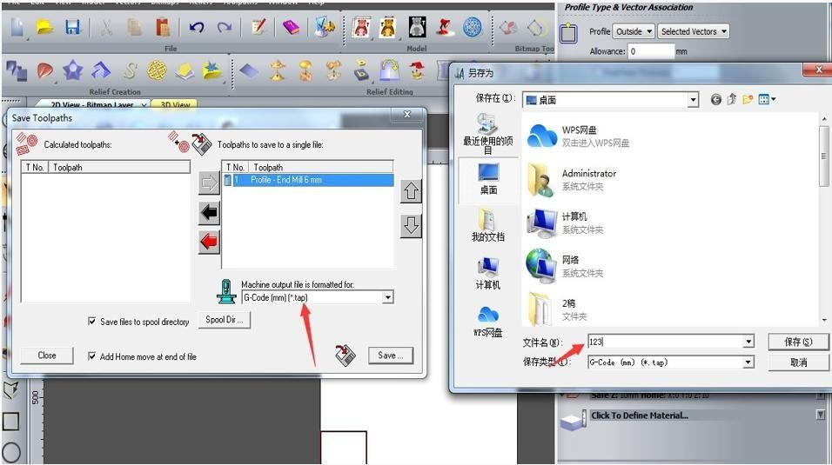

After save the gcode you can open it in text and check.

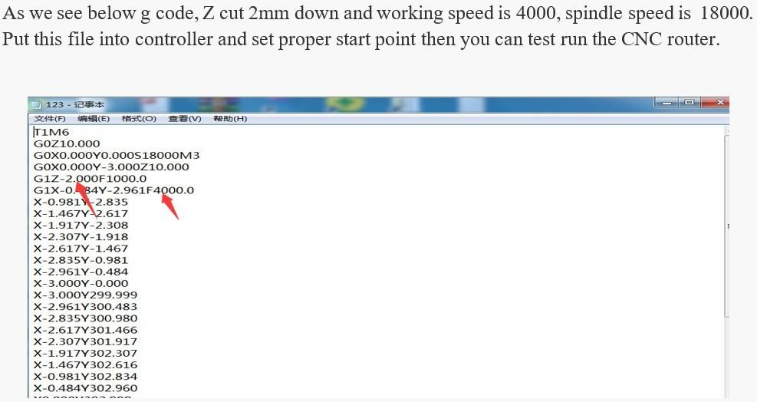

#### Additional Tips:

* **Material Considerations**: Choose appropriate materials based on your design requirements and CNC router capabilities.
* **Safety Precautions**: Follow safety protocols when operating CNC machinery to prevent accidents and ensure a safe working environment.
* **Post-Processing**: After machining, perform any necessary finishing operations such as sanding or painting to enhance the final appearance of your design.

#### Benefits of Using ArtCAM for CNC Router Design:

* **Precision and Detail**: ArtCAM’s vector and relief creation tools allow for precise control over design elements, ensuring high-quality outputs.
* **Efficiency**: The ability to simulate and optimize toolpaths helps in minimizing material waste and reducing machining time.
* **Versatility**: ArtCAM supports a wide range of materials and CNC machine types,

making it suitable for various applications from woodworking to engraving and signage.

#### Application Examples:

* **Woodworking**: Creating intricate patterns, furniture components, or decorative elements.
* **Sign Making**: Designing and cutting out letters, logos, and graphics from materials like wood, acrylic, or aluminum.
* **Artistic Sculptures**: Carving detailed sculptures and reliefs based on artistic designs.

### RESULT

Thus design for CNC router was created using ARTcam software.

# EXP.NO:17 PCB DESIGN FOR PRODUCT DEVELOPMENT DATE:25.11.25

### AIM

Create a PCB design for product Development

#### Step-by-Step Guide to PCB Design for Product Development:

1. **Requirements Gathering and Specification:**

* **Functional Requirements**: Define what the PCB needs to do—what components it will support, interfaces it needs to have, and the overall functionality it must provide.
* **Constraints**: Consider physical constraints such as size limitations, environmental factors (temperature, humidity), and electrical specifications (voltage, current).

#### Schematic Design:

* **Capture Schematic**: Use EDA (Electronic Design Automation) software like Altium Designer, Eagle, or KiCad to create a schematic diagram. Place components and connect them logically according to your requirements.
* **Component Selection**: Choose components based on their electrical characteristics, availability, cost, and suitability for your application. Ensure components are from reliable suppliers.

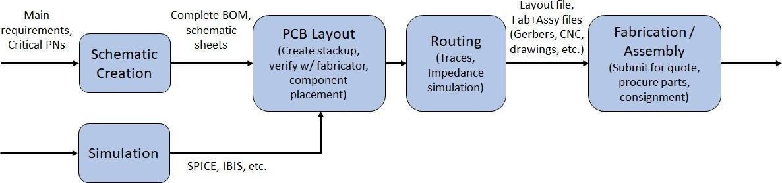

#### PCB Layout Design:

* **PCB Footprint Creation**: Create or verify footprints (physical dimensions and pad layouts) for each component used in the schematic.
* **Placement**: Arrange components on the PCB layout to optimize signal integrity, minimize noise, and facilitate ease of manufacturing (considering component height and orientation).
* **Routing**: Route traces to connect components while adhering to design rules (spacing, clearance, impedance control). Pay attention to signal integrity and power distribution to avoid noise and interference.
* **Ground and Power Planes**: Include solid ground and power planes to provide low impedance paths and improve signal integrity.

#### Design Verification:

* **Design Rule Check (DRC)**: Run a DRC to ensure your layout meets PCB fabrication capabilities and design constraints (e.g., minimum trace width, spacing, clearance).
* **Signal Integrity Analysis**: Perform simulations or use built-in tools to check signal integrity, ensuring signal quality is maintained across the board.

#### Documentation and Preparation for Manufacturing:

* **Generate Gerber Files**: Export Gerber files, which are the standard format used by PCB manufacturers to fabricate the board.
* **Bill of Materials (BOM)**: Create a BOM listing all components, their manufacturers, part numbers, and quantities required for assembly.
* **Assembly Drawings**: Prepare assembly drawings that indicate component placements, orientation, and any special instructions for assembly.

#### Prototyping and Testing:

* **Prototype Fabrication**: Order a prototype batch from a PCB manufacturer. Verify that the fabricated boards match your design specifications.
* **Functional Testing**: Test the PCB prototype to ensure it meets all functional requirements. Verify electrical performance, connectivity, and reliability under expected operating conditions.

#### Iterative Refinement:

* **Feedback Incorporation**: Based on testing results and feedback, refine the PCB design if necessary. Address any issues identified during testing to improve the design’s reliability and performance.

#### Finalization and Production:

* **Documentation**: Update all documentation including schematics, PCB layouts, BOM, and assembly instructions based on the final design.
* **Mass Production**: Once the design is finalized and tested, proceed with mass production by ordering the required quantity of PCBs from your chosen manufacturer.

### OUTPUT

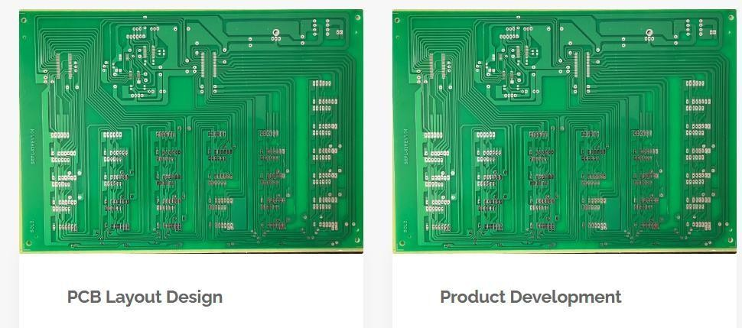

**RESULT**

Thus, Printed Circuit Board design was completed successfully.

# EXP.NO:18 MINI PROJECT DATE:2.12.25

### AIM

Create mini project design for product development.

#### Steps for Developing a Mini Project

1. **Identify a Problem or Need**
   * Look for everyday problems or areas where a small technological solution could make a difference.
   * Consider the interests and skill levels of the participants in the idea lab.

#### Brainstorm Solutions

* + Hold a brainstorming session to come up with various ideas.
  + Evaluate each idea for feasibility, complexity, and potential impact.

#### Select a Project

* + Choose a project that balances innovation with practicality.
  + Ensure it is something that can be completed within the given timeframe and resources.

#### Define the Project Scope

* + Clearly outline the goals, requirements, and constraints of the project.
  + Break down the project into smaller, manageable tasks.

#### Plan and Gather Materials

* + Create a project plan with milestones and deadlines.
  + List all necessary materials and components, ensuring they are readily available or easily sourced.

#### Design and Prototype

* + Use design software to create schematics and layouts if the project involves hardware.
  + Develop a prototype to test and refine the concept.

#### Build and Test

* + Assemble the project according to the design.
  + Test the project to ensure it meets the defined requirements and functions as intended.

#### Document and Present

* + Document the design process, including any challenges and how they were overcome.
  + Prepare a presentation or demonstration to showcase the project.

#### Example Projects

1. **Smart Plant Watering System**

**Objective**: Create a system that automatically waters plants based on soil moisture levels.

#### Components:

* Soil moisture sensor
* Arduino or Raspberry Pi
* Water pump
* Relay module
* Power supply
* Tubing and containers for water

#### Steps:

1. Connect the soil moisture sensor to the microcontroller.
2. Program the microcontroller to read moisture levels and activate the water pump when necessary.
3. Set up the water delivery system using the pump and tubing.
4. Test the system with different soil conditions and refine the code as needed.

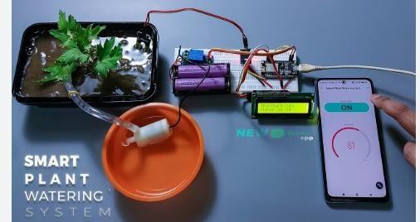

#### Home Security Alarm

**Objective**: Develop a basic home security system that detects motion and sounds an alarm.

#### Components:

* PIR motion sensor, Arduino or ESP8266/ESP32, Buzzer or alarm, LED indicator
* Power supply

#### Steps:

1. Connect the PIR motion sensor to the microcontroller.
2. Program the microcontroller to activate the buzzer and LED when motion is detected.
3. Test the system in various scenarios to ensure it reliably detects motion and triggers the alarm.

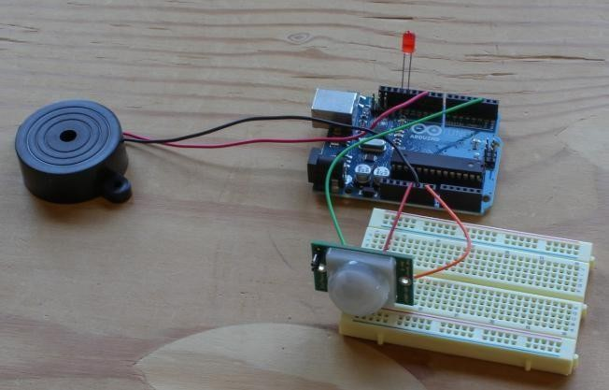

#### Temperature and Humidity Monitor

**Objective**: Build a device that monitors and displays temperature and humidity levels.

#### Components:

* DHT11 or DHT22 sensor
* Arduino or ESP8266/ESP32
* LCD display or OLED screen
* Power supply

#### Steps:

1. Connect the DHT sensor and display to the microcontroller.
2. Program the microcontroller to read data from the sensor and display it on the screen.
3. Test the system to ensure accurate readings and display functionality.

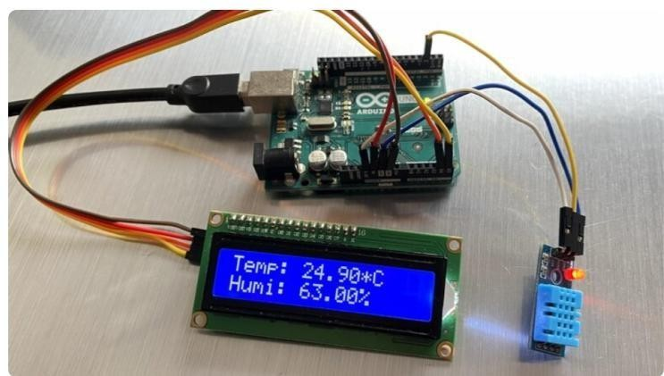

### RESULT

Thus, the mini projects was completed successfully.

**ADDITIONAL EXERCISE**

# EXP.NO:19 NOTEBOOK LM(NOTEBOOK LANGUAGE MODEL LEARNING DATE:09.12.25 BASICS OF CHATGPT)

### AIM

To demonstrate and explore the features of NotebookLM.

### INTRODUCTION

#### What is NotebookLM?

NotebookLM is an AI-powered tool designed to help users organize, analyze, and understand their notes, documents, or research materials.

It works like a combination of a smart digital notebook and an AI tutor — but only uses the content you upload.

Built using Google’s advanced **Gemini AI models**, it provides accurate, source-based responses.

#### Key Features

1. **Source-Grounded AI**

* NotebookLM relies only on the documents, notes, or files you upload.
* It does not pull information from the web or guess answers.
* This ensures accuracy and relevance to your study or project materials.

#### Ask Questions About Your Content

* You can ask the AI questions directly related to your uploaded material.
* Example:

*“Summarize this PDF.”*

*“Explain Section 2 in simple language.”*

#### Automatic Summaries

* Quickly generates summaries from long research papers, articles, or notes.
* Useful for students, researchers, and professionals handling large volumes of information.

#### Generate Drafts and Ideas

* Helps create outlines, FAQs, study guides, and structured drafts based on your documents.
* You can brainstorm and develop ideas more efficiently.

#### Organized Notebook Structure

* Files and AI-generated content stay neatly arranged within a notebook.
* You can upload, label, group files, and store the AI’s responses for future use.

#### How to Use NotebookLM

1. Sign in using your Google account at **notebooklm.google**.
2. Upload your documents (PDFs, text files, handwritten notes, etc.).
3. Ask the AI to summarize, explain, or generate content strictly from your uploaded sources.
4. Save AI-generated summaries, ideas, or explanations inside the notebook.
5. Share notebooks with others for teamwork or collaborative study.

#### Who Uses NotebookLM?

* + **Students:** Summarize lectures, understand chapters, create study guides.
  + **Researchers:** Extract insights, simplify complex papers, prepare literature summaries.
  + **Writers & Journalists:** Organize interview notes, draft articles, fact-check using source documents.
  + **Professionals:** Manage meeting notes, project files, and documentation efficiently.

#### Why NotebookLM is Useful

* + Saves time by summarizing documents quickly.
  + Minimizes manual copy-paste work.
  + Helps users effectively utilize the information they collect.
  + Keeps all files, summaries, and AI responses in one organized space.
  + Works only with your uploaded content — no external search results.
  + Maintains privacy: files and AI outputs stay linked to your Google account.

**In short:**

**NotebookLM is an intelligent notebook that reads, understands, and helps you work with your own notes and documents — faster, easier, and smarter.**

### ALGORITHM

#### Step 1:

Open the website:

[**https://notebooklm.google/**](https://notebooklm.google/) **Step 2:**

Create a new notebook.

#### Step 3:

Upload the provided file **struct.pdf** into the notebook.

#### Step 4:

Use the **Audio Overview** option to listen to the document’s contents.

#### Step 5:

Click on the **Mind Map** feature to visualize the structure and relationships within your document.

# SAMPLE OUTPUT:

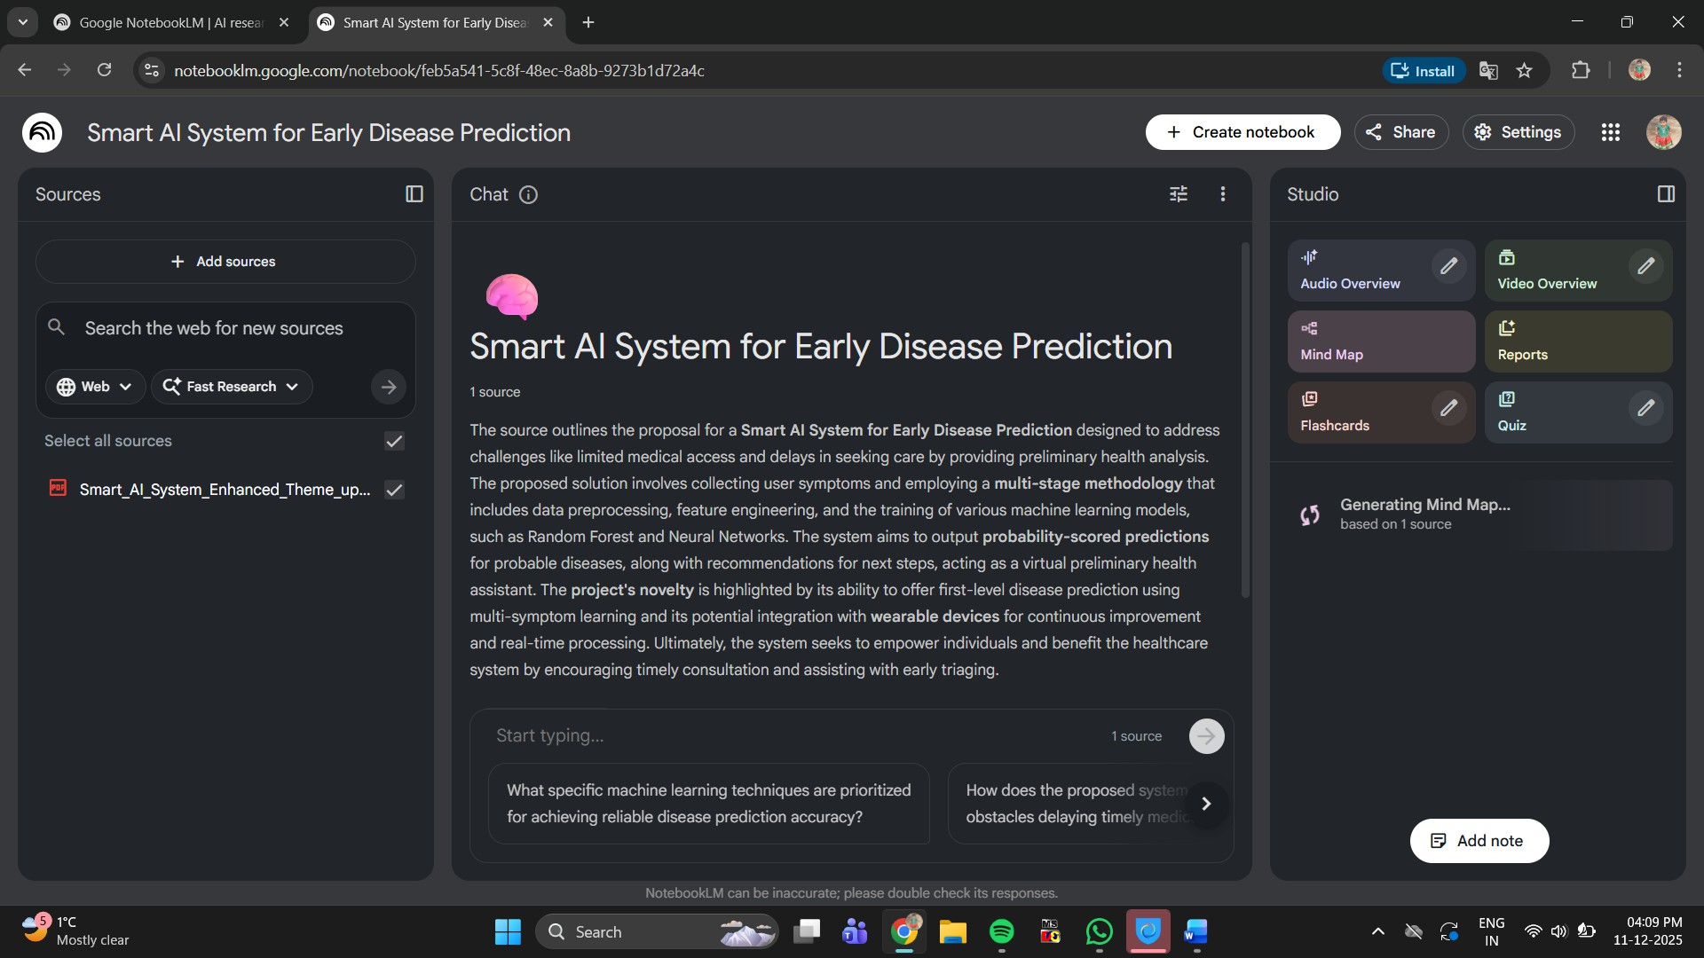

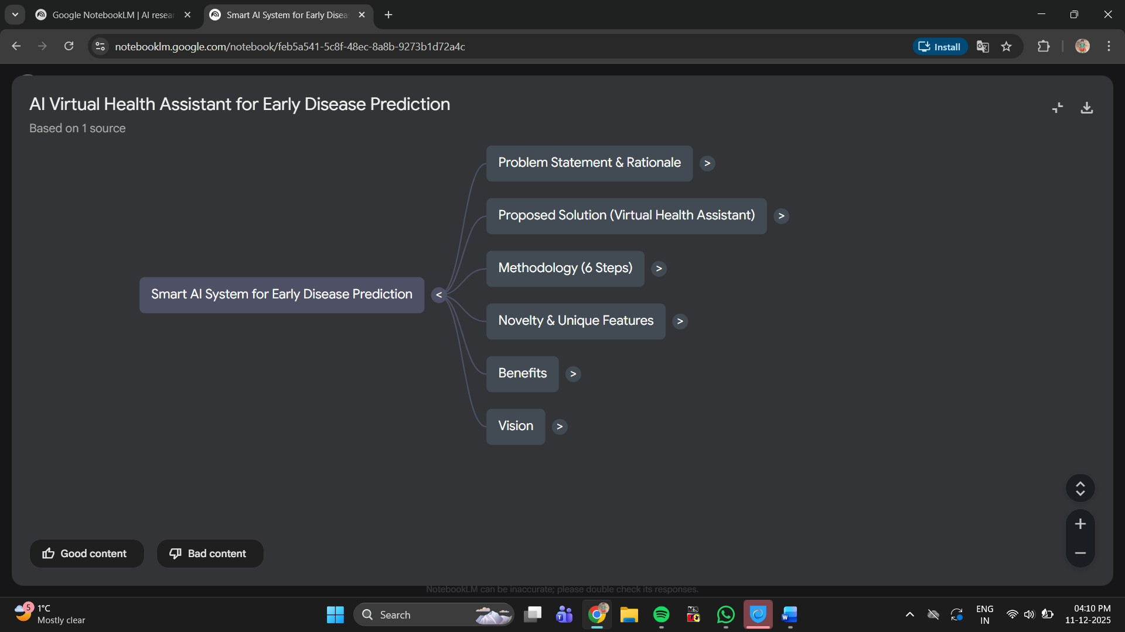

**RESULT:**

Thus the Notebook LM AI tool is demonstrated with a suitable example.

# EXP.NO:19 CREATING A WEBSITE USING GOOGLE SITES DATE:09.12.1015

**AIM**

To create a website using google sites.

# ALGORITHM:

Step 1: Access Google Sites

1. Open a web browser and visit Google Sites.
2. Log in to your Google account.
3. Click on the "+" or "Create" button to start a new website.

Step 2: click the template gallery. You can see all the templates Click blank website

Step 3 Create your site, name it and add logo

Step 4: All websites have home, contact us etc, add them. See top right. Pages option is found. Just click on it. Click new page option at the bottom

Step 5 : Add the videos, about us and contact pages using add page.

Step 6 : Click three dots in the right side. You can see make homepage, duplicate page, properties, add subpage, etc

Step 7: Click add subpage. Create 2 subpages called Tutorial and Name it as tutorial , Tips and tricks

Step 8:Set themes

Step 9:Choose vision as the theme option

Step 10 : Choose the font and color. Design each page. Now drag one of the elements. Step 11: Change the colors and the palette option

Step 12 : Edit the text and click + symbol, you add a picture or YouTube video. Add a text box below it and post the text . Create a video and provide link Click social media and link

step 13 : Add footer. Take the mouse down. Click add footer. And then you can type whatever you want to add. Similarly do for all pages.

Step 14: Before to publish go to settings icon. You can see few useful options

Step 15: Preview your website and publish it. Before to publish go to settings icon.

# SAMPLE OUTPUT:

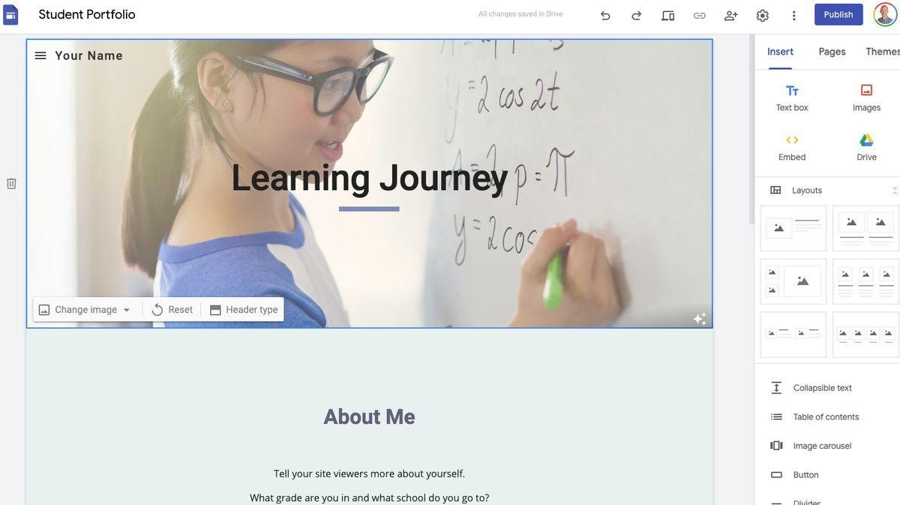

**RESULT:**

Thus a website was created using google site.

# EX.NO:19 DESIGN A GOOGLE FORM

### AIM

To design a Google Form, understand all major features, share it to collect responses, and view the response summary using Google Forms.

### SOFTWARE / TOOL REQUIRED

**Google Forms** (forms.google.com) Web browser (Chrome / Firefox / Edge) Google account

### PROCEDURE

#### Create a New Google Form

* + Open **forms.google.com**
  + Click **Blank Form**
  + Enter **Form Title** (e.g., Feedback Form)
  + Add a **Form Description** to explain its purpose.

#### Add Questions

* + Click the **+ (Add Question)** button.
  + Choose question types such as:
    1. Short Answer
    2. Paragraph
    3. Multiple Choice
    4. Checkboxes
    5. Dropdown
    6. File Upload
    7. Linear Scale
    8. Multiple Choice Grid / Checkbox Grid
    9. Date / Time
  + Mark important questions as **Required**.

#### Customize the Form

* + Click **Customize Theme**:
    1. Change header image
    2. Change background color
    3. Change font style
  + Use **Preview (eye icon)** to check form appearance.

#### Share and Collect Responses

* + Click **Send**
  + Share via:

#### Link

* + 1. **Email**
    2. **Embed HTML** (for websites)
  + Enable:
    1. *Collect email addresses* (optional)
    2. *Limit to 1 response* (optional)

#### View & Analyze Responses

* + Open **Responses** tab
  + View:
    1. Summary (charts, graphs)
    2. Question-wise responses
    3. Individual responses
  + Export responses to **Google Sheets** by clicking **Link to Sheets** con.

### ALL IMPORTANT FEATURES OF GOOGLE FORMS (EXPLAINED FOR LAB WRITE-UP)

#### ✔️ 1. Question Types

Google Forms supports multiple question formats:

* Short Answer
* Paragraph
* MCQ
* Checkboxes
* Dropdown
* File Upload
* Linear Scale
* Multiple Choice Grid
* Checkbox Grid
* Date & Time

#### ✔️ 2. Quiz Mode

* Convert any form to a quiz (Settings → Make this a Quiz)
* Add correct answers using **Answer Key**
* Assign points
* Automatic grading

#### ✔️ 3. Themes & Customization

* Add header image
* Change fonts
* Set background colors
* Adjust design layout

#### ✔️ 4. Form Sections & Logic

* Divide form into multiple sections
* Apply **Go-to-section based on answer** logic
* Used for surveys, branching questions

#### ✔️ 5. Validation Options

* + Response validation for:
    1. Email
    2. Number
    3. Text length
    4. Regular expressions
  + Ensures correct data entry

#### ✔️ 6. Response Management

* View responses in:

#### Summary

* 1. **Question**
  2. **Individual** view
* Download responses
* Export to Google Sheets
* Generate charts automatically

#### ✔️ 7. Sharing Features

* Send via email
* Copy form link
* Create QR code
* Embed in website
* Restrict to organization users

#### ✔️ 8. Settings Options

Includes important controls:

* Collect Email Addresses

.. .. Limit to 1 Response

* Allow Editing After Submission
* Show Summary to Respondents
* Enable/Disable Quiz mode
* Shuffle Question Order

SAMPLE OUTPUT:

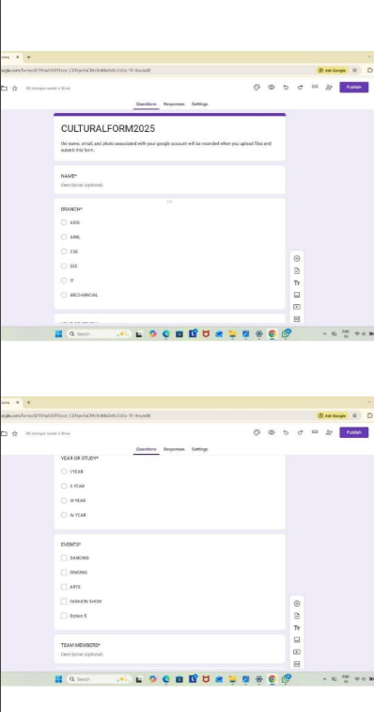

**RESULT**

Thus, a Google Form was successfully created, customized, shared to collect responses, and all major features of Google Forms were understood and explained.

# EXP.NO:19 INTERACTIVE PROJECT PRESENTATION USING GOOGLE SLIDES

### AIM

To create an interactive project presentation using Google Slides by adding structured content, design elements, and interactive navigation links to enhance user engagement. **ALGORITHM**

#### Step 1: Open Google Slides

1. Sign in to your Google account.
2. Open Google Slides from the Google Apps menu or slides.google.com.
3. Create a new blank presentation.
4. Rename the presentation appropriately.
5. Choose a layout or theme to begin with.

#### Step 2: Plan the Structure of the Presentation

1. Decide the start, middle, and end sections of your project.
2. Determine how many slides are required.
3. Allocate content to each slide.
4. Identify where interactive elements will be used.
5. Arrange slides in logical order.

#### Step 3: Add Content to Slides

1. Insert titles, subtitles, and short descriptions.
2. Add images, shapes, icons, tables, or charts as needed.
3. Use bullet points for clarity and readability.
4. Maintain a clean layout for all slides.
5. Keep information minimal and focused.

#### Step 4: Insert Interactive Elements

1. Select text, shapes, or images to convert into interactive buttons.
2. Add hyperlinks to connect slides internally.
3. Add links to external websites if required.
4. Insert buttons like “Home,” “Next,” and “Back.”
5. Apply smooth animations and transitions for engagement.

#### Step 5: Customize the Design

1. Choose a suitable theme that matches the project.
2. Adjust font style, size, and color for readability.
3. Use alignment tools for clean positioning of elements.
4. Ensure consistency in design across all slides.
5. Use high-quality visuals to enhance appearance.

#### Step 6: Review and Test Interactivity

1. Run the presentation in slideshow mode.
2. Click on all buttons and links to ensure proper functioning.
3. Check for spelling, spacing, and formatting errors.
4. Adjust animations and pacing if needed.
5. Make corrections to finalize the presentation.

#### Step 7: Present or Share the Slides

1. Use the “Present” button to deliver the presentation.
2. Share the link for collaboration or viewing.
3. Change access permissions (view/comment/edit) as required.
4. Download as PPT, PDF, or video if needed.
5. Save all changes and close the project. **SAMPLE OUTPUT:**

# SAMPLE OUTPUT:

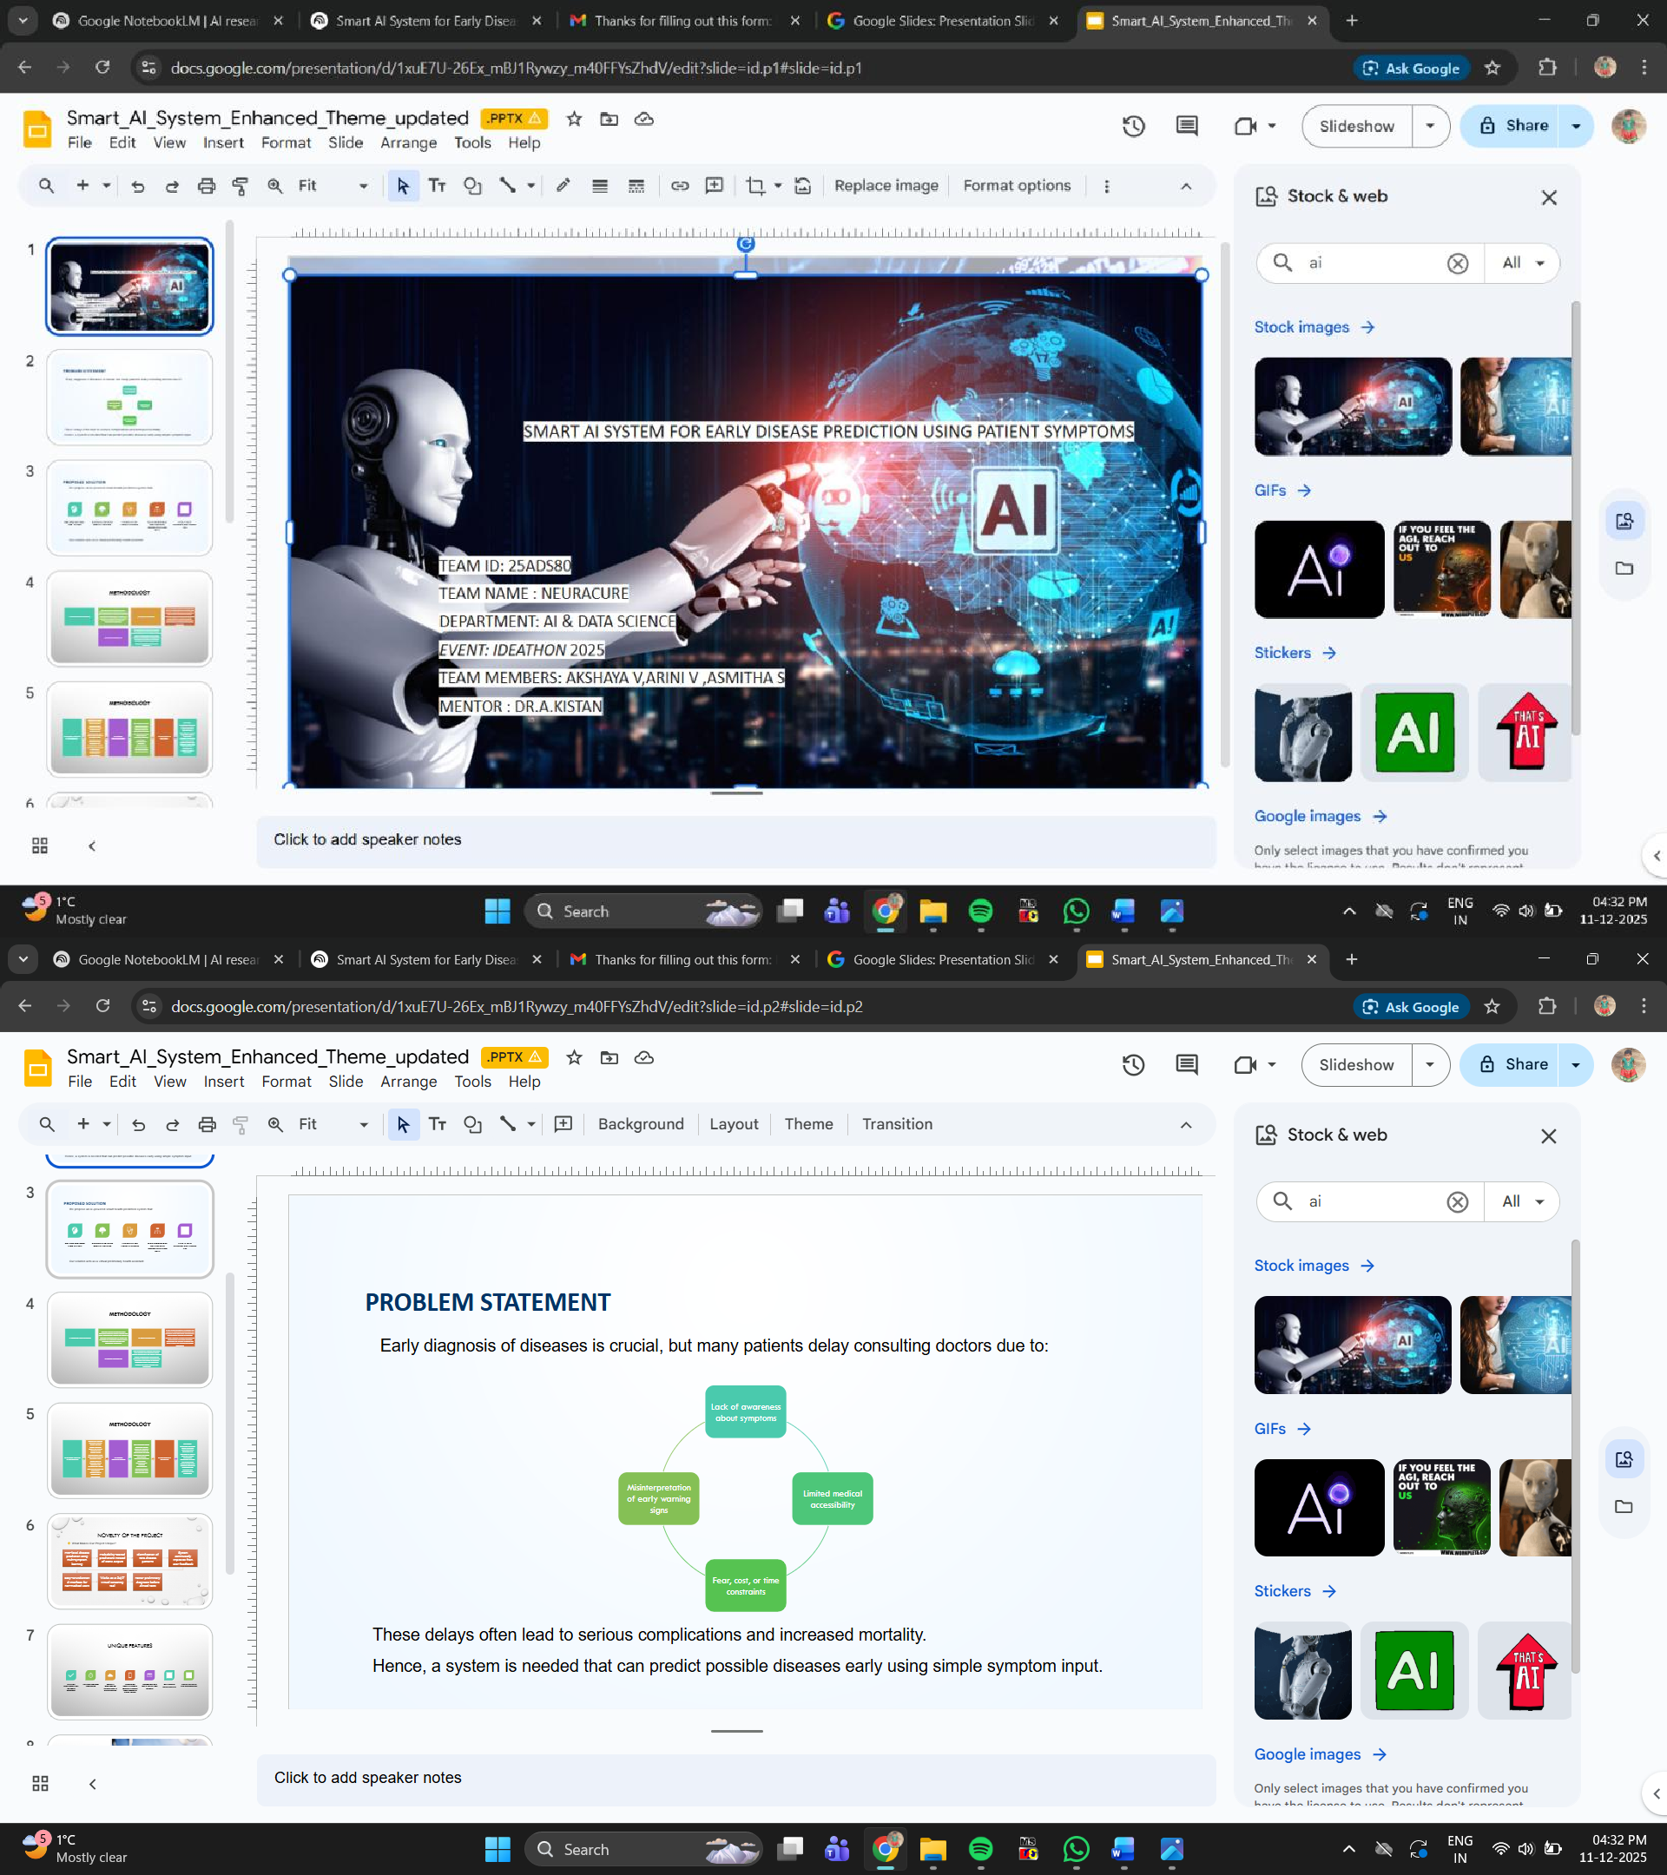

### RESULT

Thus, an interactive project presentation was successfully created using Google Slides, incorporating navigation elements, visual design, and structured content.